

DEPARTMENT OF COMPUTER SCIENCES

DATA MINING
DS-303

LAB MANUAL

INSTRUCTOR 2023-BS-AI-020
MR ARHAM MISHAL NADEEM
CONTENTS

Sr. No. | Lab No. | Topic | Page No.
1 | Lab 1 | Introduction to Data Mining | 3
2 | Lab 2 | CRISP-DM Process | 10
3 | Lab 3 | Handling Missing Values, Duplicates & Noise | 17
4 | Lab 4 | Normalization, Standardization & Discretization | 20
5 | Lab 5 | Market Basket Analysis | 24
6 | Lab 6 | Apriori Algorithm | 27
7 | Lab 7 | FP-Tree Construction & FP-Growth | 30
8 | Lab 8 | Python Syntax & Basics | 33
9 | Lab 9 | Decision Tree Classifier | 38
10 | Lab 10 | Naïve Bayes & KNN | 45
11 | Lab 11 | Support Vector Machine (SVM) | 50
12 | Lab 12 | K-Means & Hierarchical Clustering | 55
13 | Lab 13 | Outlier Detection | 61
14 | Lab 14 | Data Scraping & Sentiment Analysis | 67
15 | Lab 15 | Performance Comparison of Models | 73

Lab 1

Introduction to Data Mining

Objective
To understand the fundamentals of Data Mining and become familiar with the KNIME analytics platform used for data processing, analysis, and machine learning.
1. Introduction to Data Mining
Data Mining is the process of extracting useful information, hidden patterns, and valuable knowledge from large datasets. It is an important field that combines techniques from statistics, machine learning, database systems, and artificial intelligence. Data mining helps organizations transform raw data into meaningful insights that support better decision-making.
Modern organizations generate enormous amounts of data through business transactions, social media, sensors, websites, and various digital systems. Data mining enables analysts to explore this data and discover relationships, trends, and patterns that would otherwise remain unnoticed.
2. Importance of Data Mining
- Converts raw data into useful information.
- Supports data-driven decision making.
- Identifies hidden patterns and trends.
- Improves business performance and efficiency.
- Helps predict future outcomes and behaviors.
- Assists in risk management and fraud detection.
- Enhances customer relationship management.
3. Data Mining Process
3.1 Data Collection
- Gathering data from multiple sources such as databases, spreadsheets, websites, and sensors.
3.2 Data Cleaning
- Removing missing values, duplicate records, and inconsistencies.
- Improving data quality for accurate analysis.
3.3 Data Transformation
- Converting data into a suitable format for analysis.
- Normalizing and organizing data structures.
3.4 Pattern Discovery
- Applying algorithms to identify relationships and trends within data.
3.5 Evaluation and Interpretation
- Analyzing results and validating discovered patterns.
- Converting findings into actionable knowledge.
4. Common Data Mining Techniques
Classification
- Assigns data into predefined categories or classes.
- Example: Email spam detection.
Clustering
- Groups similar data objects together.
- Example: Customer segmentation.
Association Rule Mining
- Discovers relationships between items in a dataset.
- Example: Market basket analysis.
Regression
- Predicts continuous numerical values.
- Example: House price prediction.
Anomaly Detection
- Identifies unusual or suspicious data patterns.
- Example: Credit card fraud detection.
6. Introduction to KNIME
KNIME (Konstanz Information Miner) is an open-source data analytics, reporting, and integration platform. It provides a graphical interface that allows users to create data analysis workflows using drag-and-drop components called nodes.
KNIME simplifies data mining and machine learning tasks by enabling users to build workflows visually without extensive programming knowledge.
7. Features of KNIME
Visual Workflow Design
- Drag-and-drop interface.
- Easy workflow creation and management.
Data Integration
- Supports CSV, Excel, databases, cloud storage, and web services.
Data Preprocessing
- Data cleaning and transformation tools.
- Missing value handling and filtering options.
Machine Learning Support
- Classification algorithms.
- Clustering algorithms.
- Regression models.
- Model evaluation tools.
Data Visualization
- Charts and graphs for data exploration.
- Interactive dashboards and reports.
Integration with Programming Languages
- Supports Python integration.
- Supports R integration.
- Extensible through community plugins.
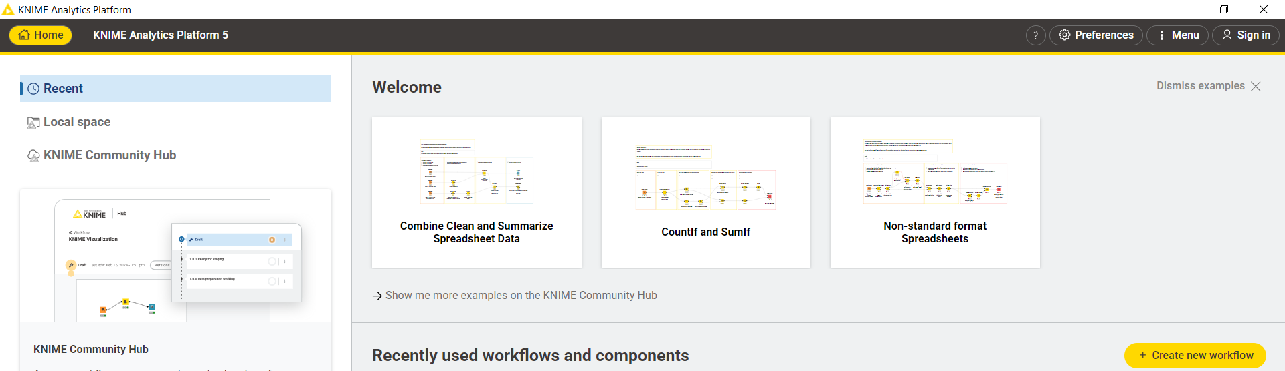

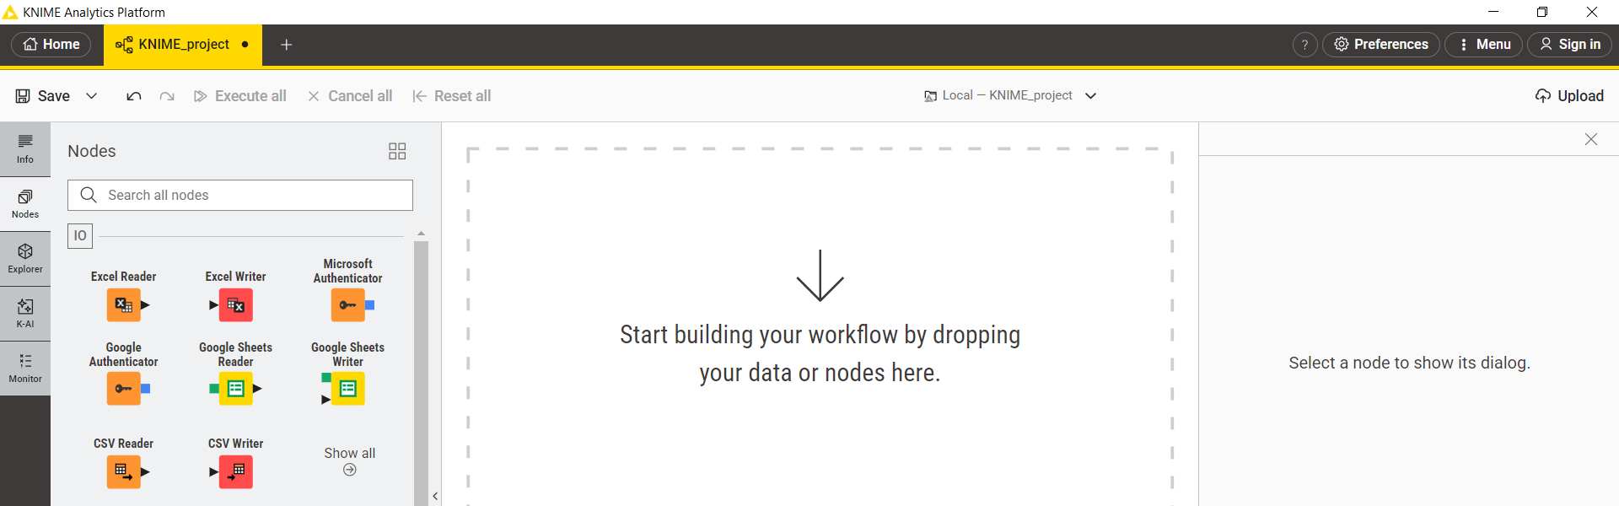

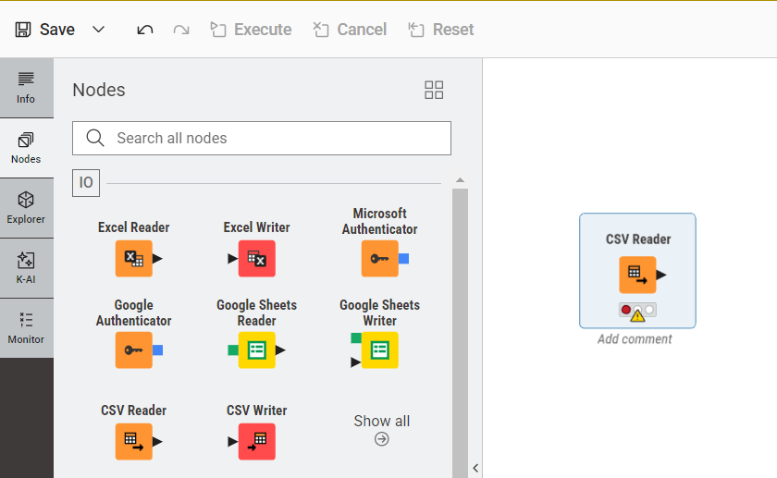
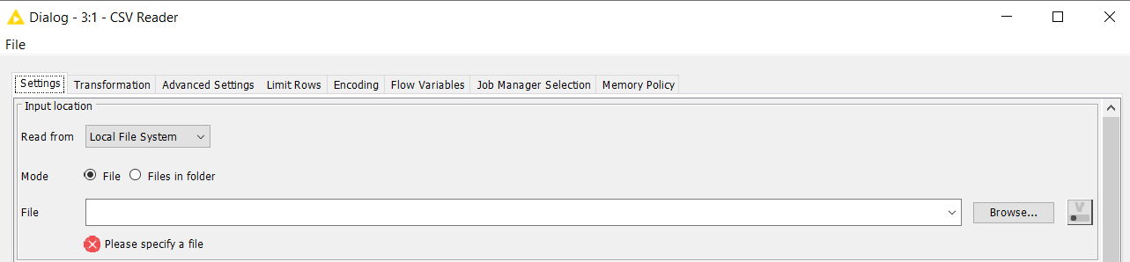

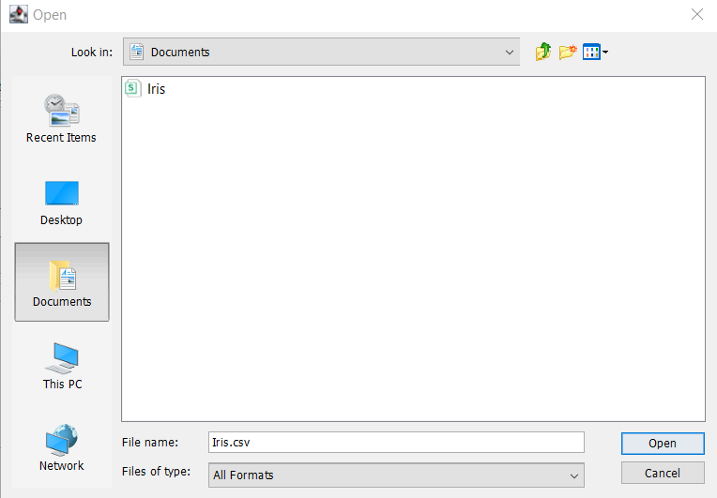
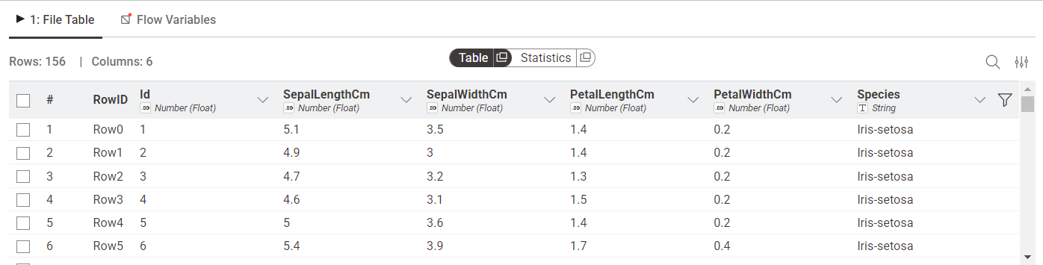
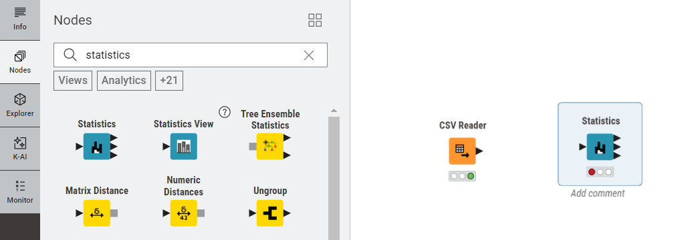
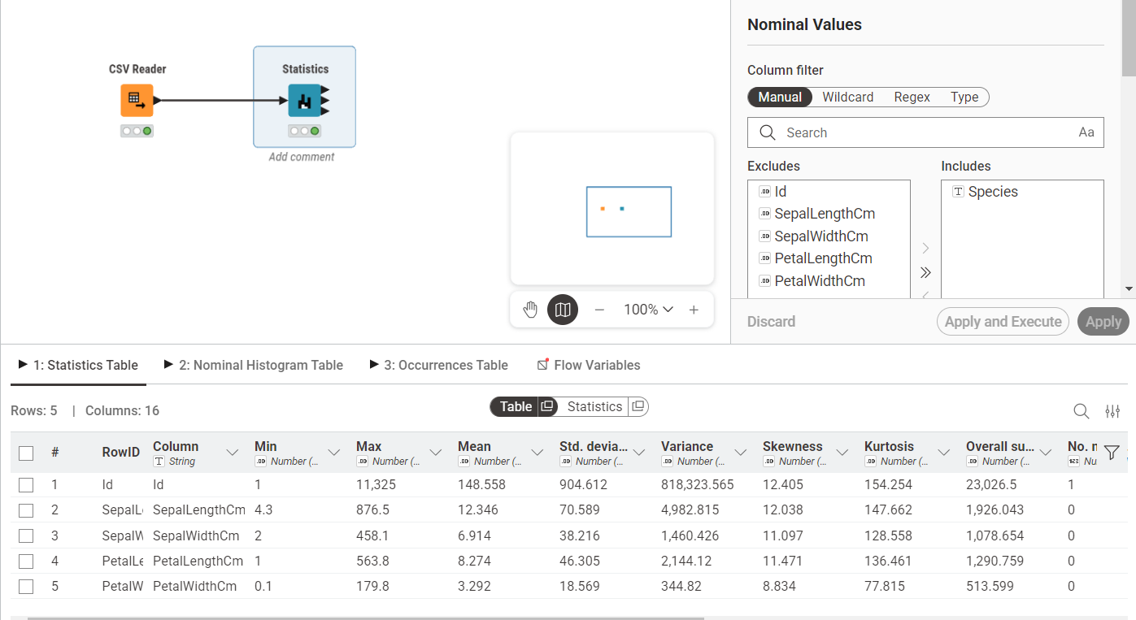
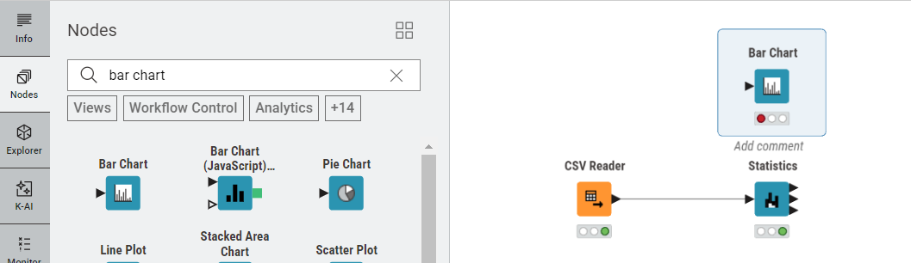
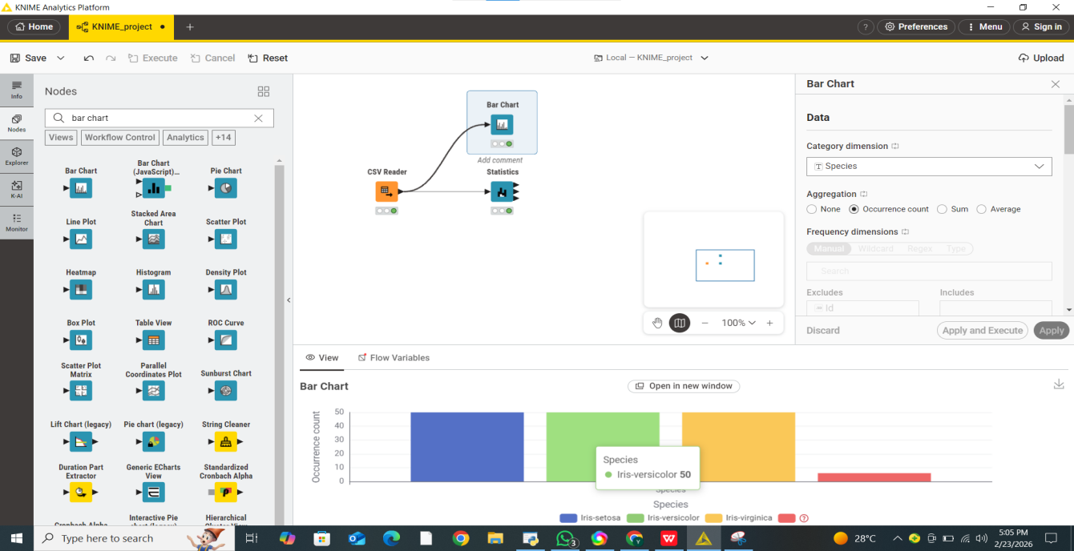

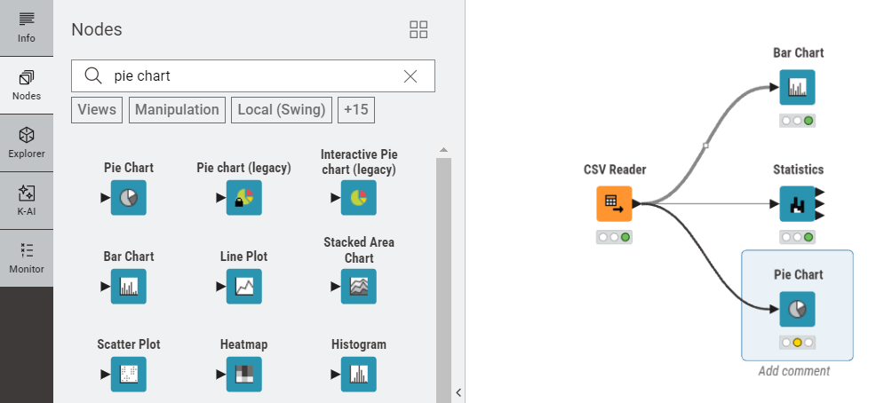
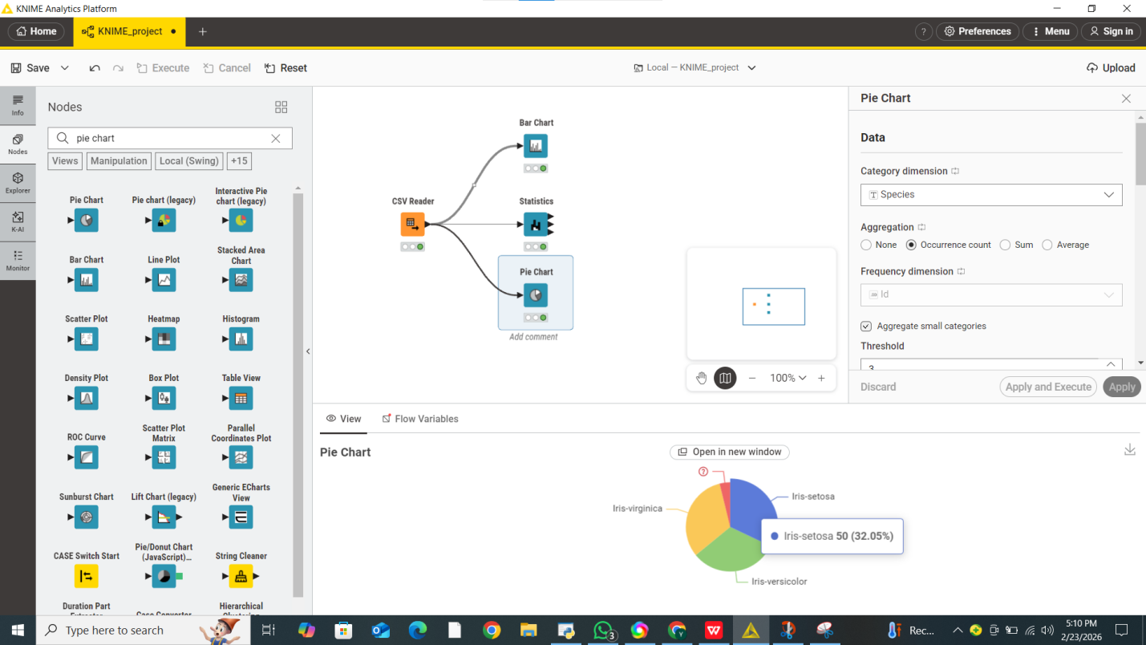

Lab 2

CRISP-DM Process

Objective
To understand the CRISP-DM methodology and explore the basic features of Orange Data Mining software.
1. Introduction to CRISP-DM
CRISP-DM (Cross-Industry Standard Process for Data Mining) is a widely used framework for managing data mining projects. It provides a structured approach for transforming business problems into data-driven solutions. The methodology is flexible and can be applied across different industries and domains.
2. Phases of CRISP-DM
2.1 Business Understanding
- Define business objectives and project goals.
- Identify project requirements and success criteria.
2.2 Data Understanding
- Collect and explore data.
- Identify data quality issues and patterns.
2.3 Data Preparation
- Clean and transform data.
- Handle missing values and select relevant features.
2.4 Modeling
- Apply machine learning or data mining algorithms.
- Train and test models.
2.5 Evaluation
- Assess model performance.
- Verify that results meet business objectives.
2.6 Deployment
- Implement the model for practical use.
- Monitor and maintain system performance.
4. Introduction to Orange Software
Orange is an open-source data mining and machine learning tool that uses a visual programming approach. Users can create workflows by connecting widgets through a drag-and-drop interface, making data analysis easier without extensive coding.
5. Features of Orange
Visual Workflow Design
- Drag-and-drop interface.
- Easy workflow creation.
Data Preprocessing
- Data cleaning and transformation.
- Feature selection tools.
Machine Learning
- Classification, clustering, and regression algorithms.
- Model evaluation capabilities.
Data Visualization
- Interactive charts and graphs.
- Easy exploration of datasets.

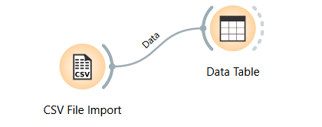
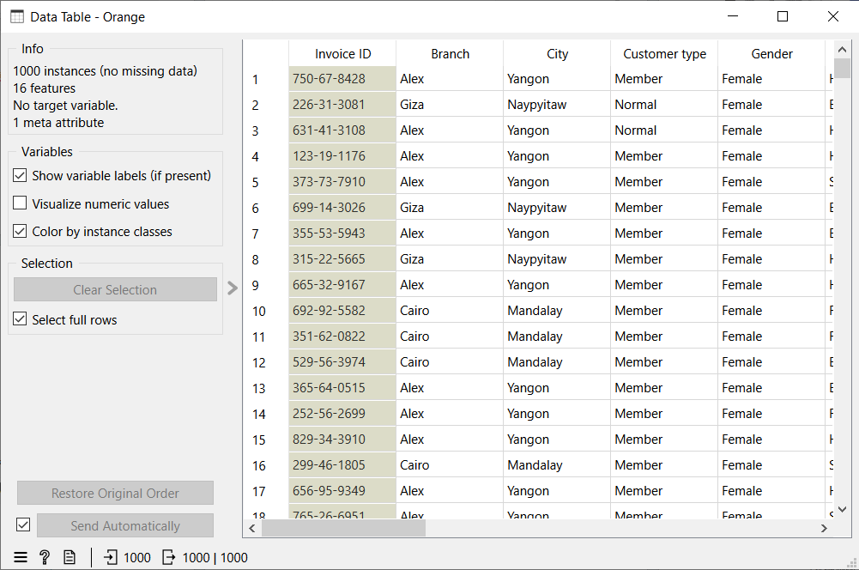
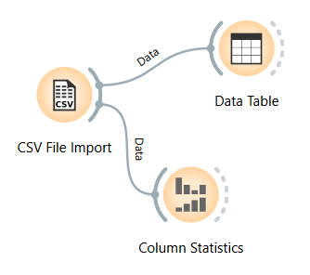
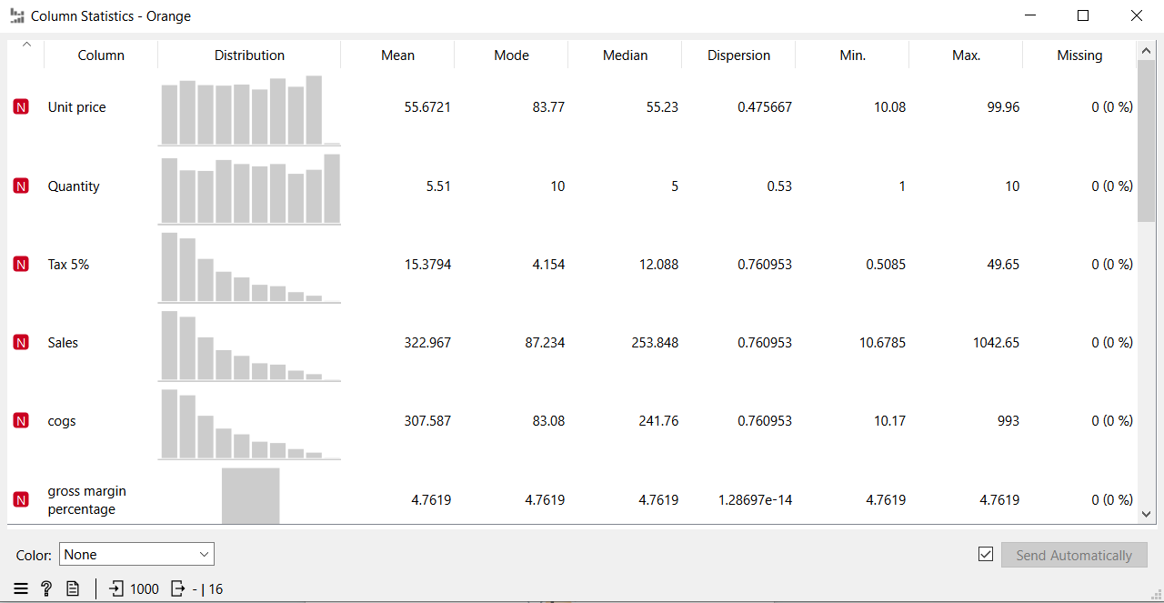
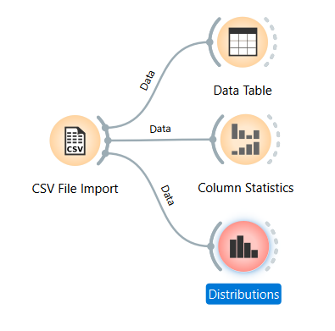
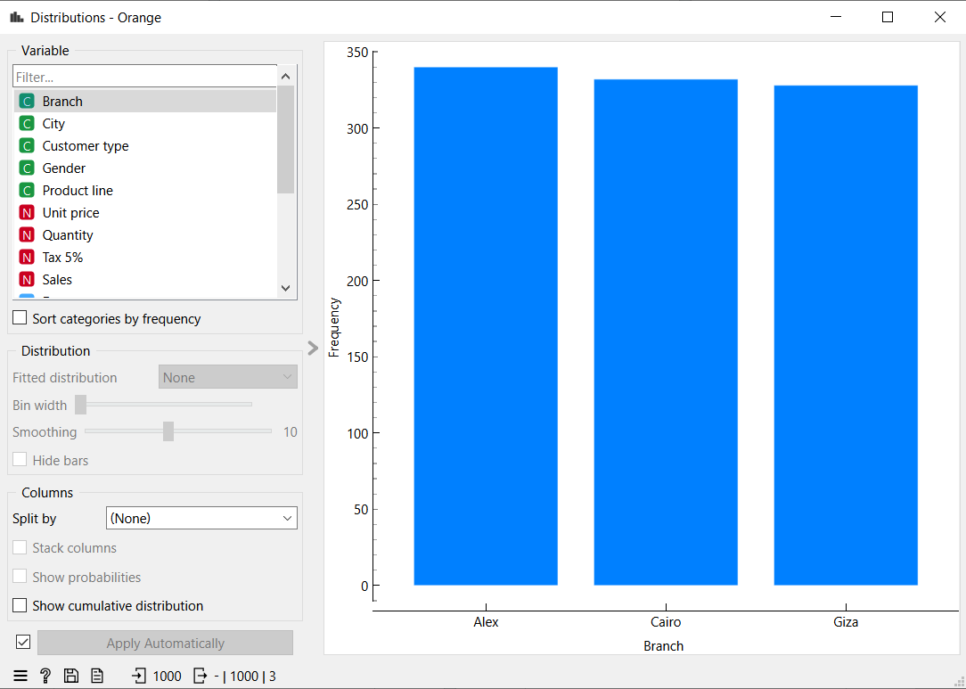
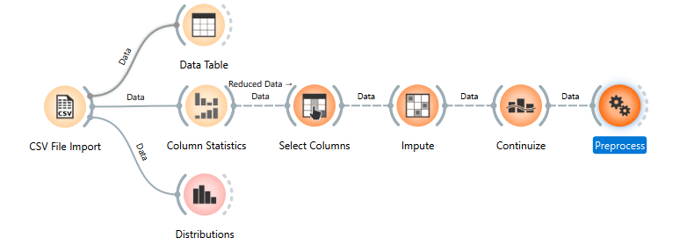
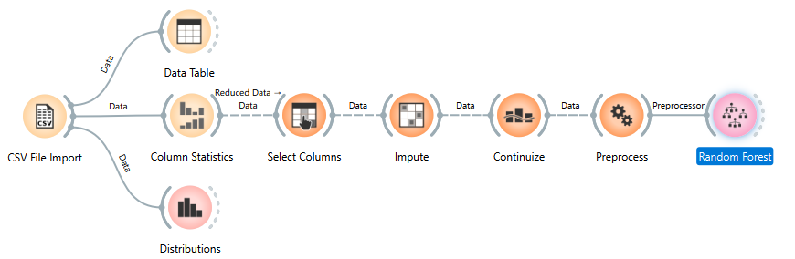

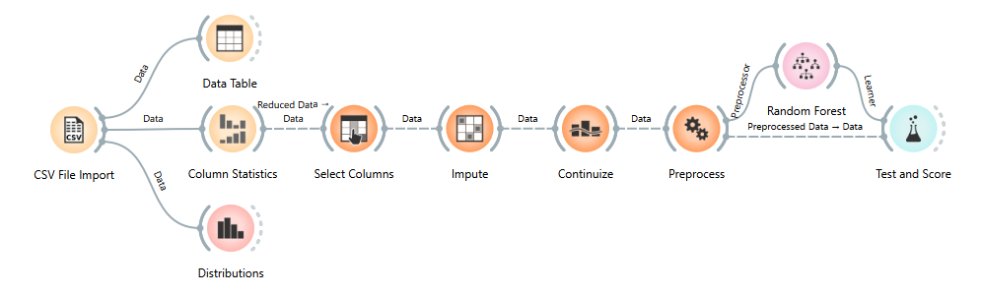
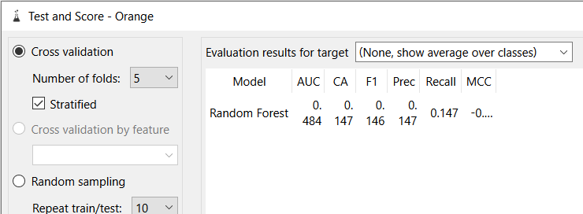
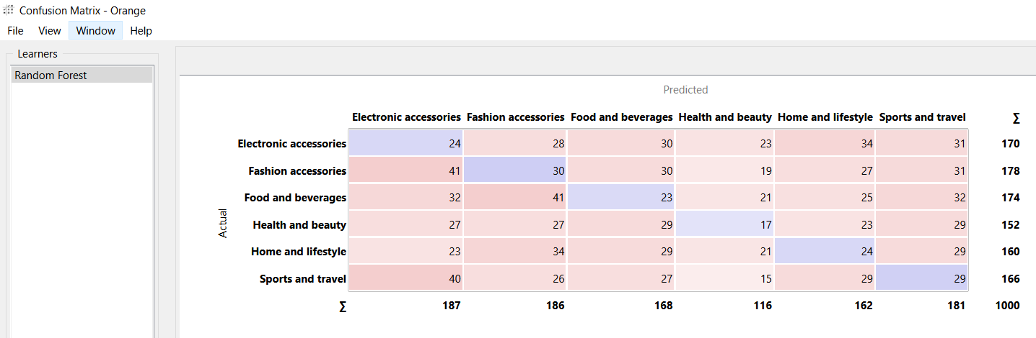
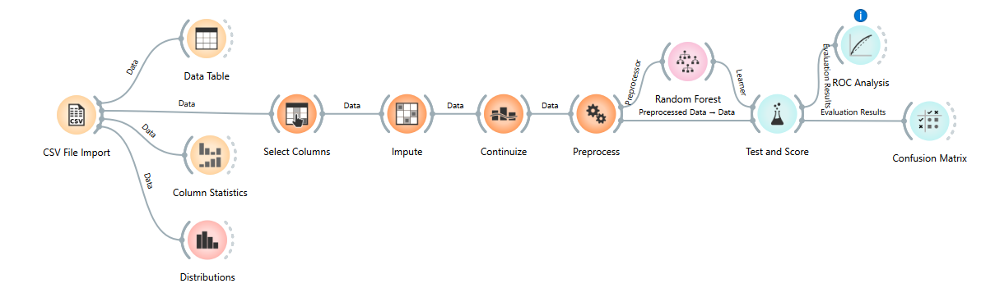
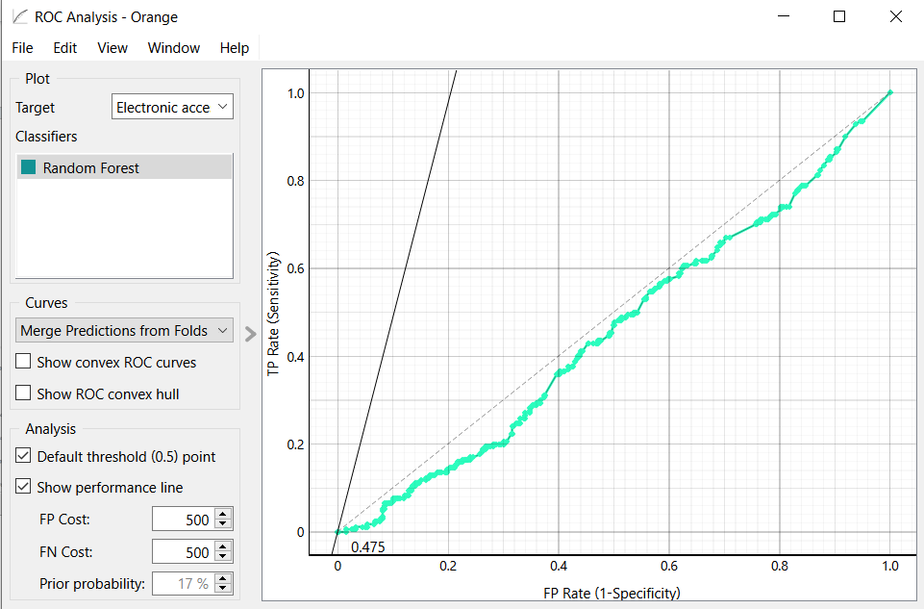

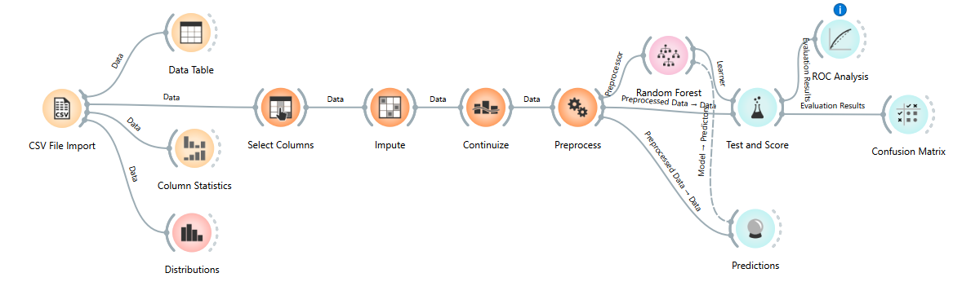
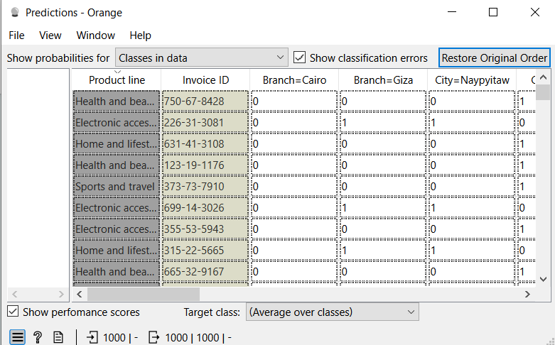

Lab 3

Handling Missing Values, Duplicates & Noise
窗体顶端

Objective
To understand the importance of data cleaning and learn techniques for handling missing values, duplicate records, and noisy data in a dataset.
1. Introduction
Data preprocessing is an essential step in data mining and machine learning. Real-world datasets often contain missing values, duplicate records, and noisy data that can negatively affect the accuracy and reliability of analysis. Data cleaning helps improve data quality and ensures better results from data mining models.
2. Handling Missing Values
Missing values occur when information for one or more attributes is unavailable.
Causes of Missing Values
- Data entry errors.
- Equipment or sensor failures.
- Incomplete surveys or forms.
- Data collection issues.
Methods for Handling Missing Values
- Removing records with missing values.
- Replacing missing values with mean, median, or mode.
- Using prediction techniques to estimate missing values.
- Filling values based on domain knowledge.
3. Handling Duplicate Records
Duplicate records occur when the same data entry appears multiple times in a dataset.
Causes of Duplicates
- Repeated data entry.
- Data integration from multiple sources.
- System or processing errors.
Methods for Handling Duplicates
- Identifying duplicate rows.
- Removing repeated records.
- Using unique identifiers for verification.
4. Handling Noisy Data
Noisy data refers to incorrect, inconsistent, or irrelevant values present in a dataset.
Causes of Noise
- Human errors.
- Faulty data collection devices.
- Transmission errors.
- Measurement inaccuracies.
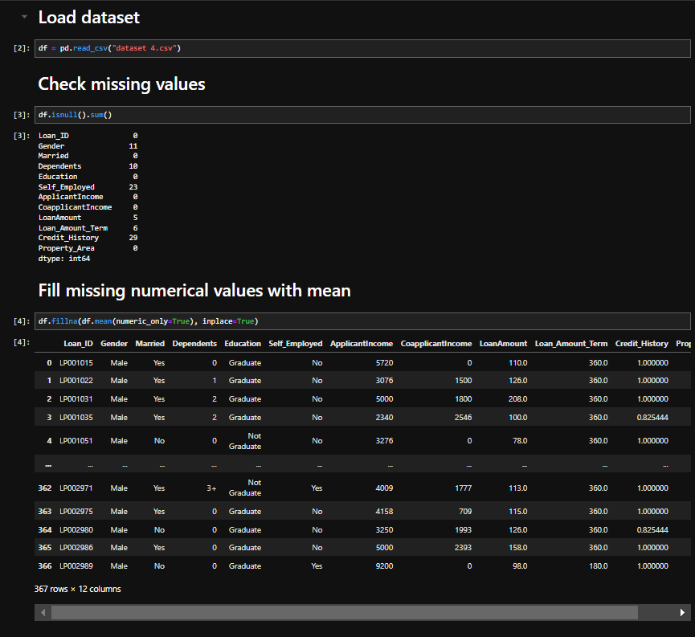

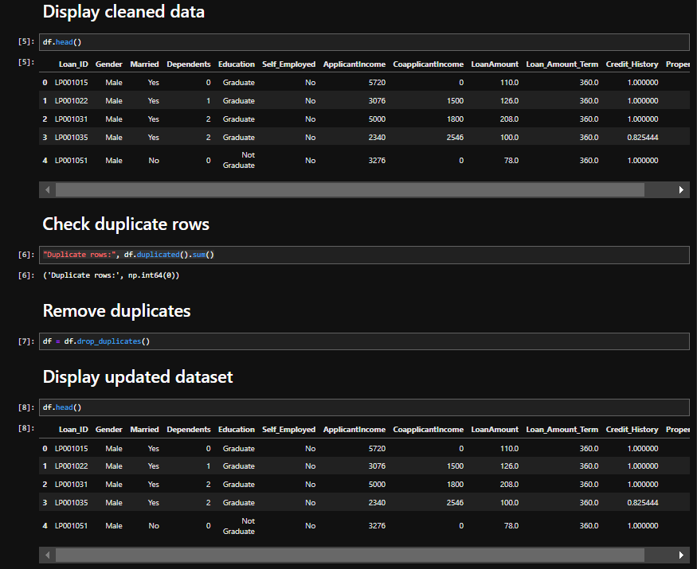
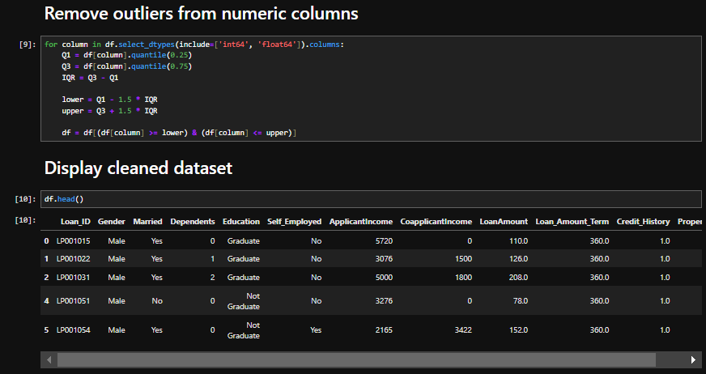

Lab 4

Normalization, Standardization & Discretization

Objective
To understand the techniques of Normalization, Standardization, and Discretization used in data preprocessing for improving data quality and model performance.
1. Introduction
Data preprocessing is an important step in data mining and machine learning. Datasets often contain attributes with different scales and formats, which can affect the performance of analytical models. Normalization, Standardization, and Discretization are preprocessing techniques used to transform data into a suitable form for analysis.
2. Normalization
Normalization is the process of scaling numerical values to a specific range, usually between 0 and 1. It ensures that all attributes contribute equally to the analysis regardless of their original scale.
Purpose
- Bring data to a common scale.
- Reduce the impact of large numerical values.
- Improve algorithm performance.
3. Standardization
Standardization is the process of transforming data so that it has a mean of 0 and a standard deviation of 1. It is commonly used when data follows a normal distribution.
Purpose
- Remove scale differences between attributes.
- Center data around the mean.
- Improve model accuracy.
4. Discretization
Discretization is the process of converting continuous numerical values into a limited number of categories or intervals. It simplifies data and makes patterns easier to understand.
Purpose
- Transform continuous data into categorical data.
- Reduce data complexity.
- Improve interpretability.
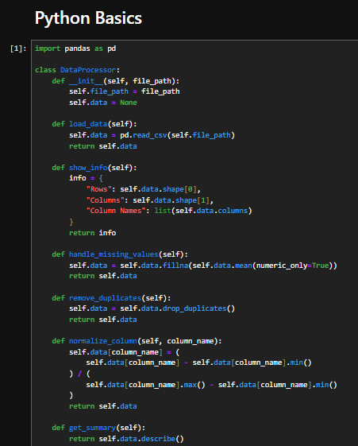
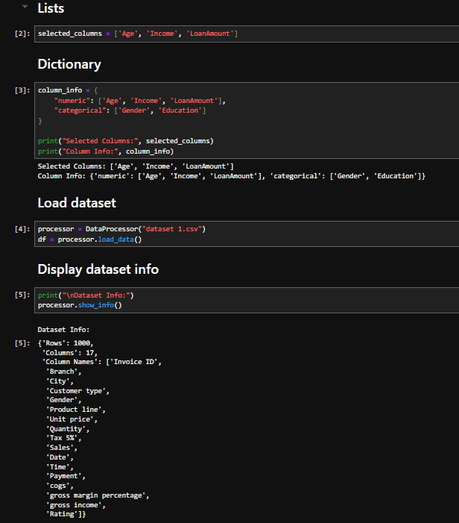
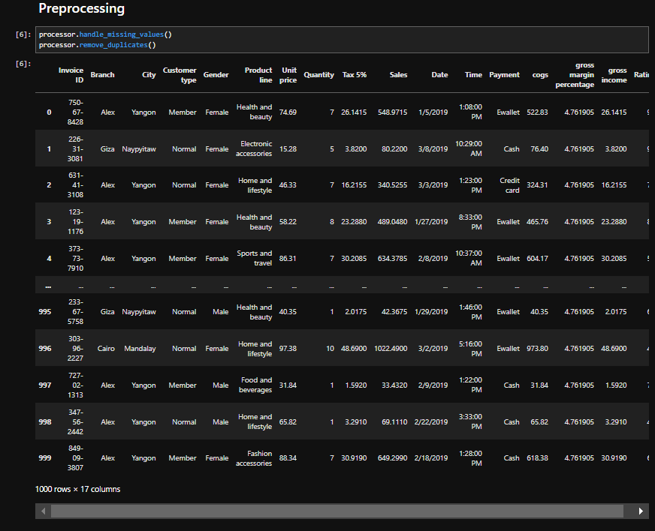
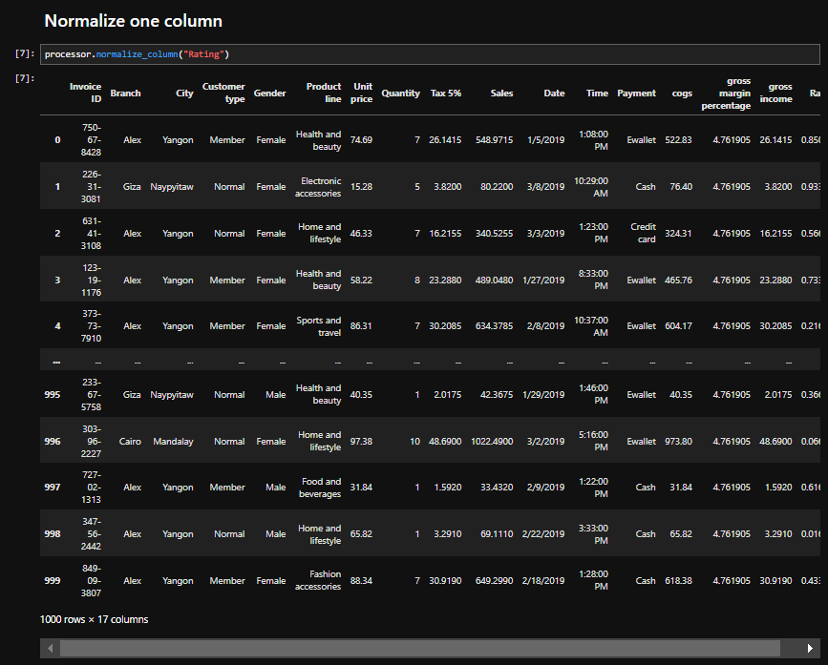
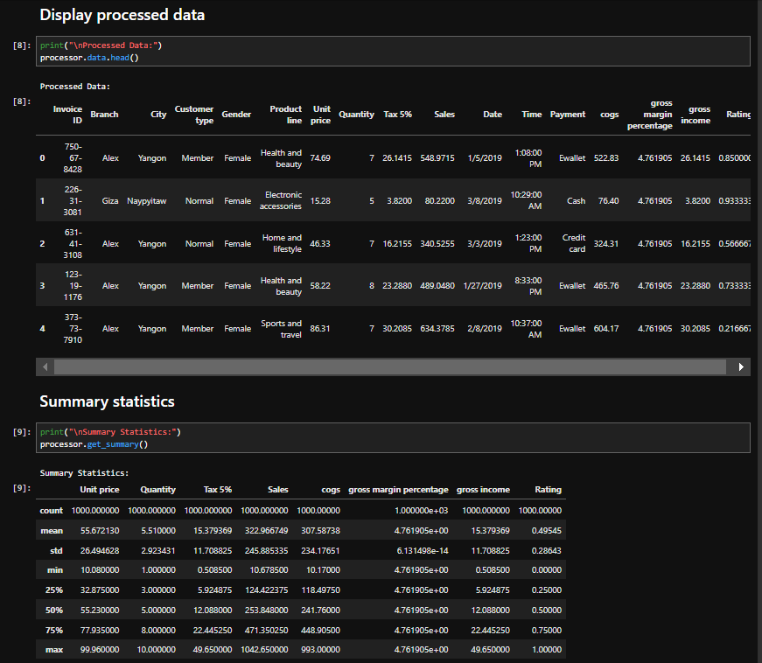

Lab 5

Market Basket Analysis

Objective
To understand the concept of Market Basket Analysis and its role in discovering relationships between items purchased together in transactional data.
1. Introduction
Market Basket Analysis (MBA) is a data mining technique used to identify associations and relationships between products frequently purchased together by customers. It helps businesses understand customer buying behavior and discover patterns within transaction data.
The technique is widely used in retail stores, supermarkets, and e-commerce platforms to improve sales, marketing strategies, and product placement.
2. Working of Market Basket Analysis
Market Basket Analysis examines customer transactions to find combinations of items that occur together frequently. Based on these patterns, businesses can make recommendations and promotional offers.
Process
- Collect transaction data.
- Identify frequent itemsets.
- Generate association rules.
- Analyze relationships between products.
- Apply findings to business decisions.
3. Key Measures
1. Support
2. Confidence
3. Lift
4. Association Rules
Association rules are expressed in the form:
If Item A is purchased, then Item B is also likely to be purchased.

Example
- Bread → Butter
- Laptop → Mouse
- Tea → Biscuits
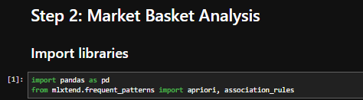
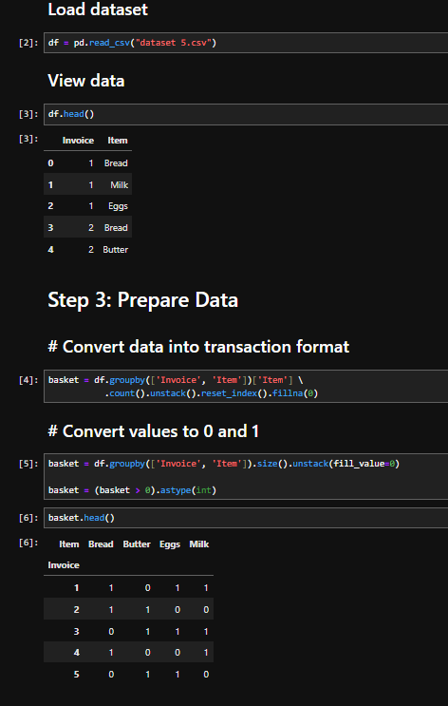
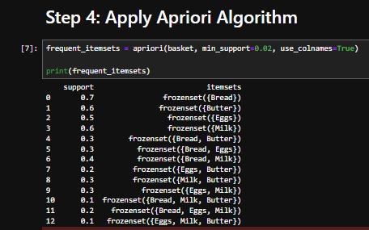
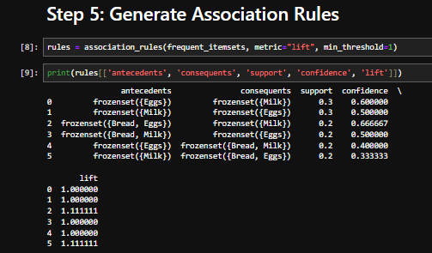

Lab 6

Apriori Algorithm

Objective
To understand the Apriori Algorithm and its use in discovering frequent itemsets and association rules from transactional data.
1. Introduction
The Apriori Algorithm is one of the most widely used algorithms in data mining for association rule mining and Market Basket Analysis. It is designed to identify frequent itemsets in a dataset and generate association rules that reveal relationships among items.
The algorithm is based on the principle that if an itemset is frequent, then all of its subsets must also be frequent. This property helps reduce the search space and improves efficiency.
2. Working of Apriori Algorithm
Apriori works by scanning the transaction database multiple times to find item combinations that satisfy a minimum support threshold.
Steps of the Algorithm
- Generate frequent 1-itemsets.
- Remove itemsets that do not meet minimum support.
- Generate candidate 2-itemsets from frequent 1-itemsets.
- Repeat the process for larger itemsets.
- Generate association rules from the frequent itemsets.
3. Key Concepts
Frequent Itemset
A group of items that appears together frequently in transactions.
Support
- Measures how often an itemset appears in the dataset.
- Used to identify frequent itemsets.
Confidence
- Measures the reliability of an association rule.
- Indicates how often the rule is correct.
Lift
- Measures the strength of the relationship between items.
- Helps determine whether associations are meaningful.
4. Apriori Principle
The Apriori Principle states:
"If an itemset is frequent, then all of its subsets must also be frequent."
This principle allows the algorithm to eliminate itemsets that cannot possibly be frequent, reducing computational effort.
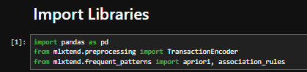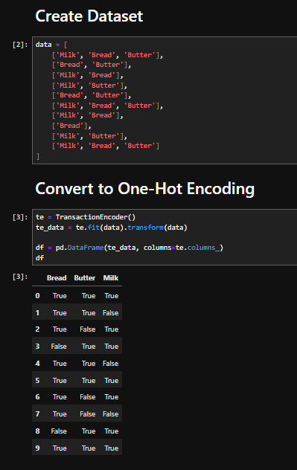
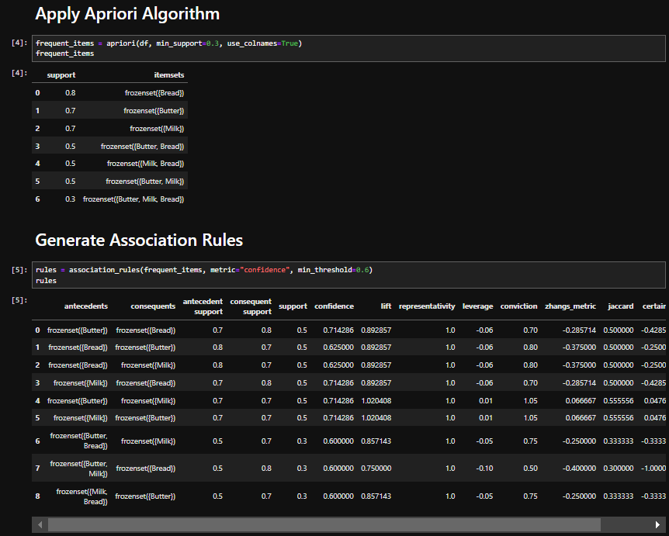

Lab 7

FP-Tree Construction & FP-Growth

Objective
To understand the construction of an FP-Tree (Frequent Pattern Tree) and the working of the FP-Growth algorithm for discovering frequent itemsets efficiently.
1. Introduction
FP-Growth (Frequent Pattern Growth) is a popular data mining algorithm used for frequent itemset mining and association rule learning. It was developed as an alternative to the Apriori Algorithm to overcome the problem of generating a large number of candidate itemsets.
The FP-Growth algorithm uses a compact data structure called the FP-Tree (Frequent Pattern Tree) to store transaction data and discover frequent patterns efficiently.
2. FP-Tree (Frequent Pattern Tree)
An FP-Tree is a tree-based structure that compresses transaction data while preserving itemset association information.
Characteristics of FP-Tree
- Compact representation of transaction data.
- Stores only frequent items.
- Reduces database scans.
- Preserves item relationships.
- Improves mining efficiency.
3. Construction of FP-Tree
The FP-Tree is constructed through the following steps:
Step 1: Scan the Database
- Count the frequency of each item.
- Remove items that do not satisfy the minimum support threshold.
Step 2: Sort Frequent Items
- Arrange items in descending order of frequency.
Step 3: Create the Tree
- Insert transactions into the tree.
- Share common prefixes among transactions.
- Update node counts accordingly.
Step 4: Create Header Table
- Maintain links to similar items in different branches of the tree.
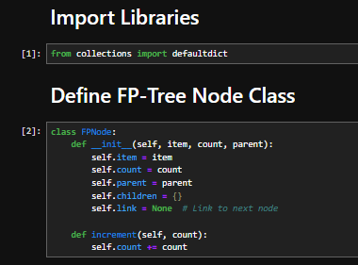
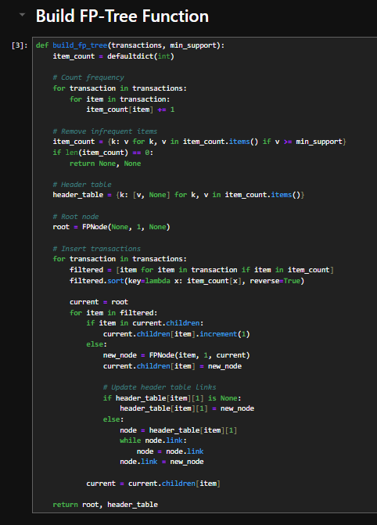
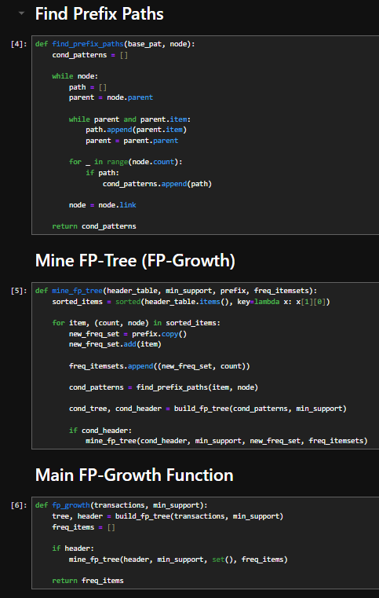
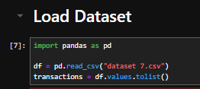
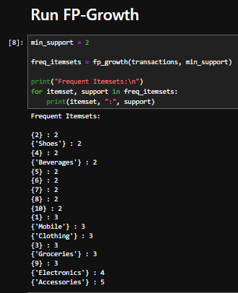

Lab 8

Python Syntax & Basics

Objective
To understand basic Python syntax and fundamental programming concepts used in data mining and data analysis tasks.
1. Introduction
Python is one of the most widely used programming languages in data mining due to its simplicity, readability, and powerful libraries such as Pandas, NumPy, and Scikit-learn. It allows data scientists to efficiently perform data preprocessing, analysis, visualization, and model building.
In data mining, Python is mainly used to handle datasets, clean data, perform calculations, and apply machine learning algorithms.
2. Python Syntax Basics
2.1 Variables
- Variables are used to store data values.
- Python does not require explicit declaration of data types.
Importance in Data Mining
- Used to store dataset values, features, and model outputs.
2.2 Data Types
- Integer (int)
- Float (decimal values)
- String (text data)
- Boolean (True/False)
Importance in Data Mining
- Helps define type of dataset attributes.
- Used for classification and numerical analysis.
2.3 Lists and Arrays
- Lists store multiple values in a single variable.
- Similar to arrays in data processing.
Importance in Data Mining
- Used to store datasets, records, and feature values.
2.4 Conditional Statements
- if, elif, else statements are used for decision-making.
Importance in Data Mining
- Used for filtering data.
- Helps in classification logic.
2.5 Loops
- for loop and while loop are used for iteration.
Importance in Data Mining
- Used to process large datasets row by row.
- Helpful in feature extraction and preprocessing.
2.6 Functions
- Functions are reusable blocks of code.
Importance in Data Mining
- Used to build preprocessing pipelines.
- Helps modularize data processing steps.
3. Python Libraries for Data Mining
NumPy
- Used for numerical operations and arrays.
Pandas
- Used for data manipulation and dataset handling.
Matplotlib / Seaborn
- Used for data visualization.
Scikit-learn
- Used for machine learning algorithms.

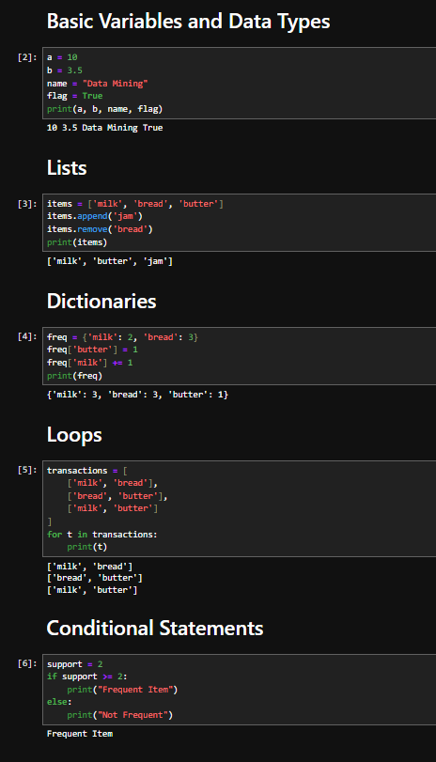
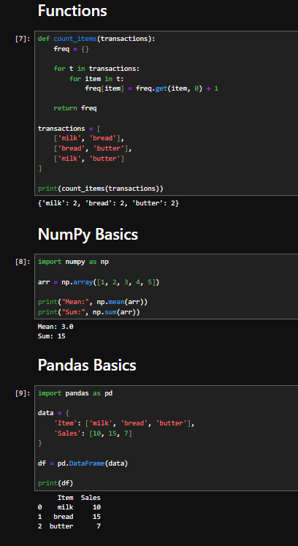
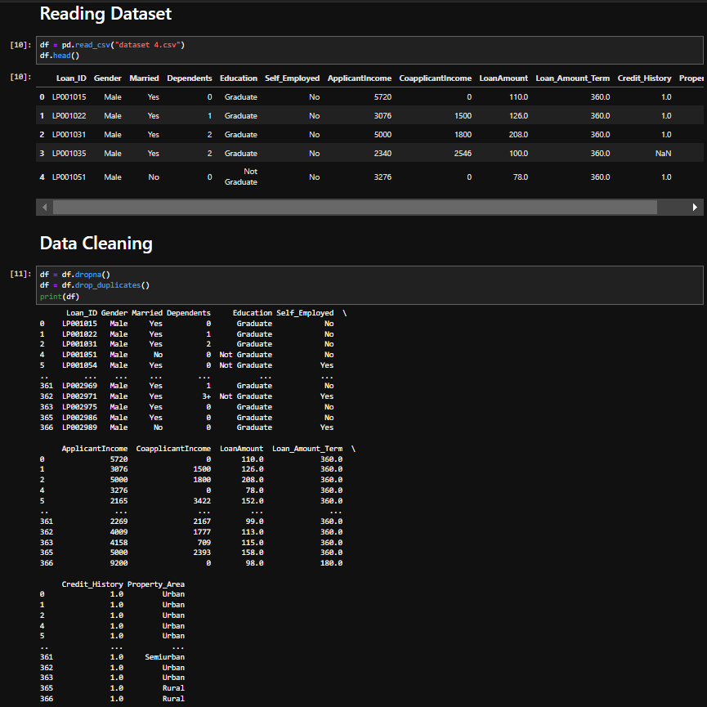
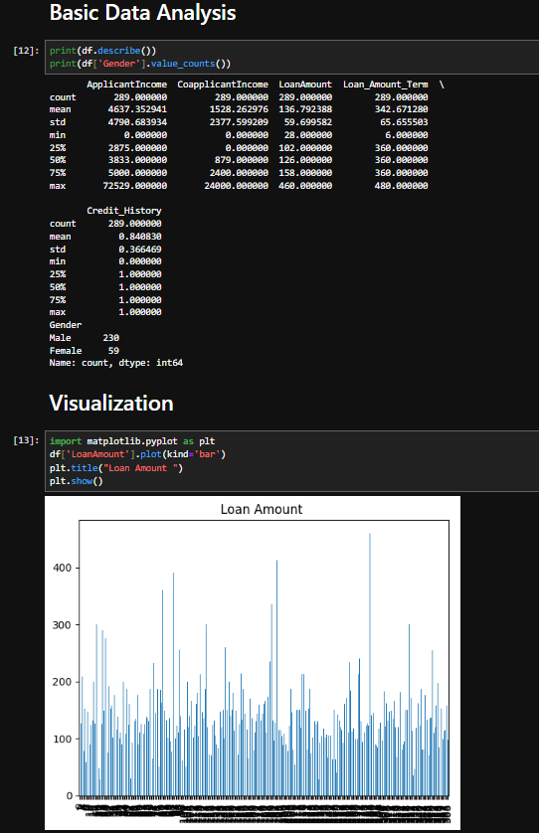

Lab 9

Decision Tree Classifier

Objective
To understand the concept of Decision Tree Classifier and its use in solving classification problems in data mining and machine learning.

1. Introduction
A Decision Tree Classifier is a supervised machine learning algorithm used for classification tasks. It works by splitting data into branches based on feature values and making decisions in a tree-like structure. Each internal node represents a decision based on an attribute, and each leaf node represents a class label or final output.
Decision trees are widely used in data mining because they are easy to understand, interpret, and implement.

2. Structure of Decision Tree

Root Node
- The top node of the tree.
- Represents the entire dataset.

Decision Nodes
- Nodes where data is split based on a feature.

Leaf Nodes
- Final output nodes.
- Represent class labels or decisions.

3. Working of Decision Tree Classifier

Step 1: Select Best Attribute
- The algorithm selects the best feature to split the dataset.
- Selection is based on criteria like Gini Index or Information Gain.

Step 2: Split Dataset
- Data is divided into subsets based on selected attribute.

Step 3: Repeat Process
- Splitting continues recursively for each subset.

Step 4: Stop Condition
- Tree stops when:
  - All data belongs to one class.
  - No attributes are left.
  - Predefined depth is reached.
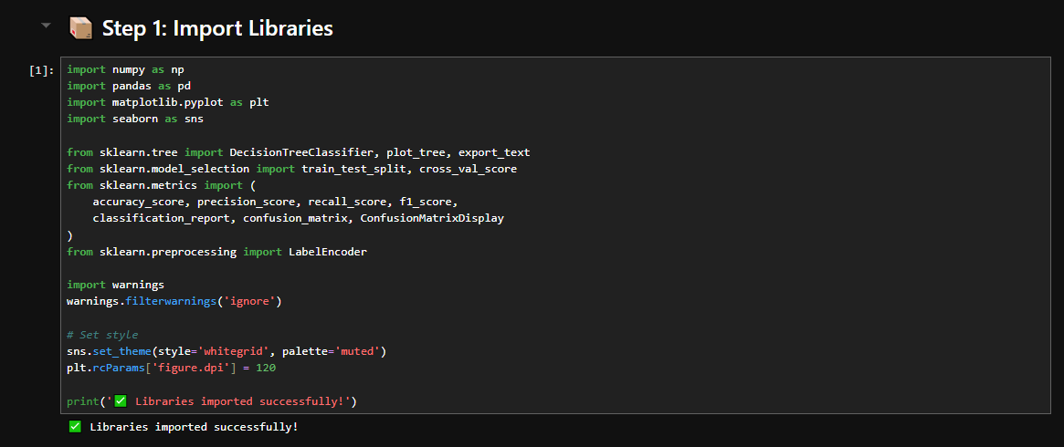
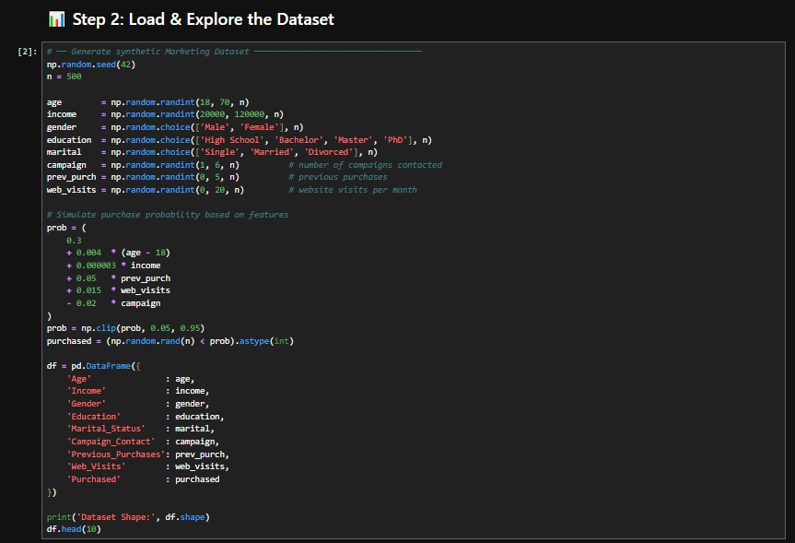

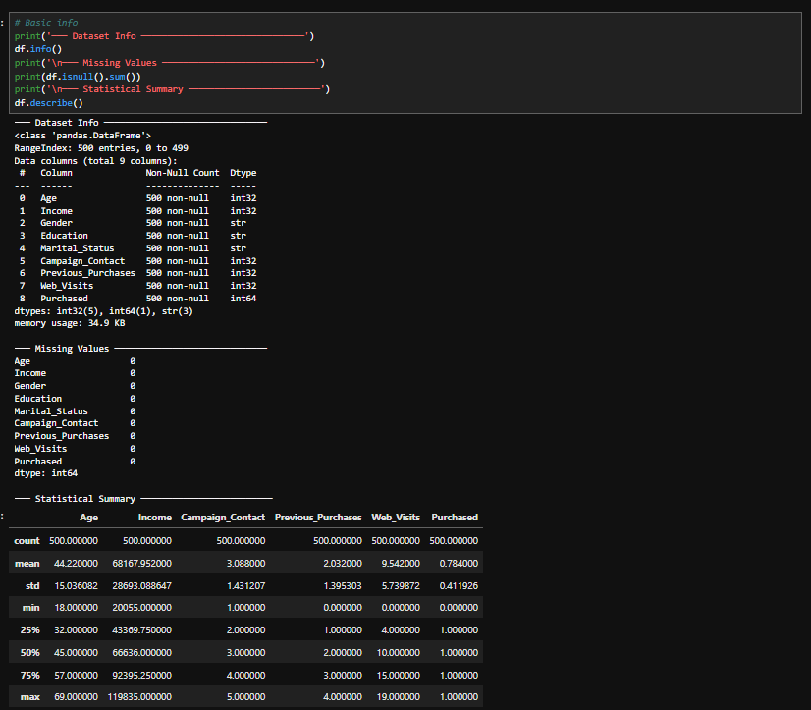
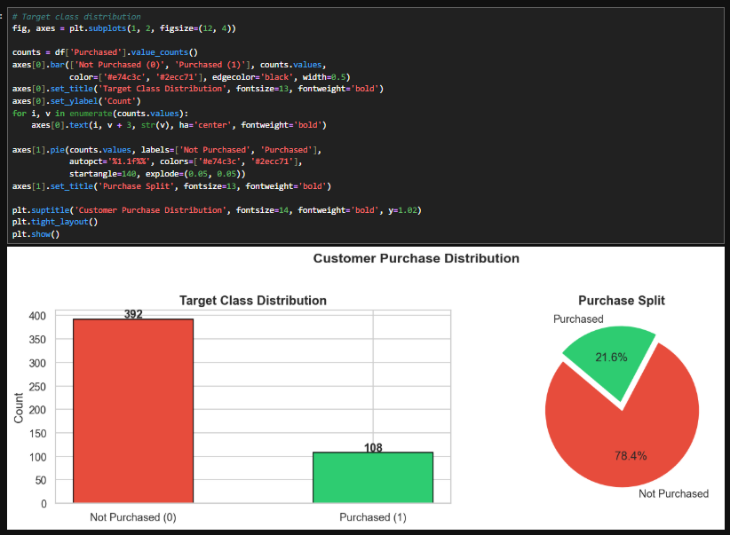
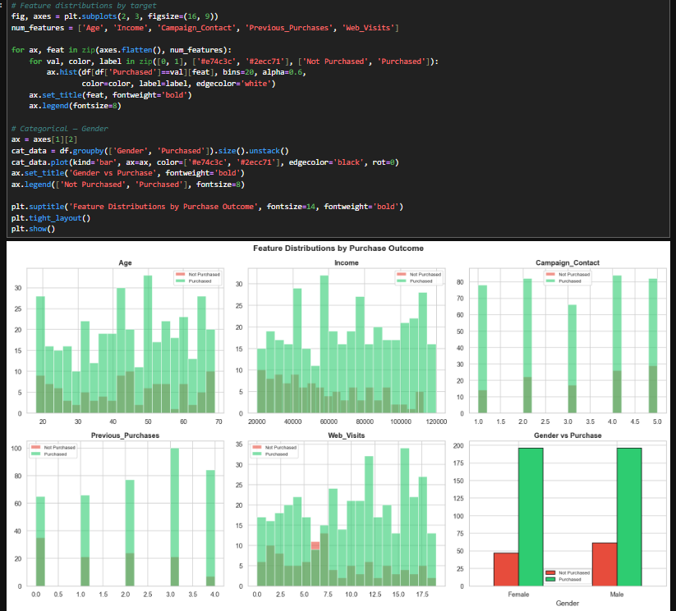
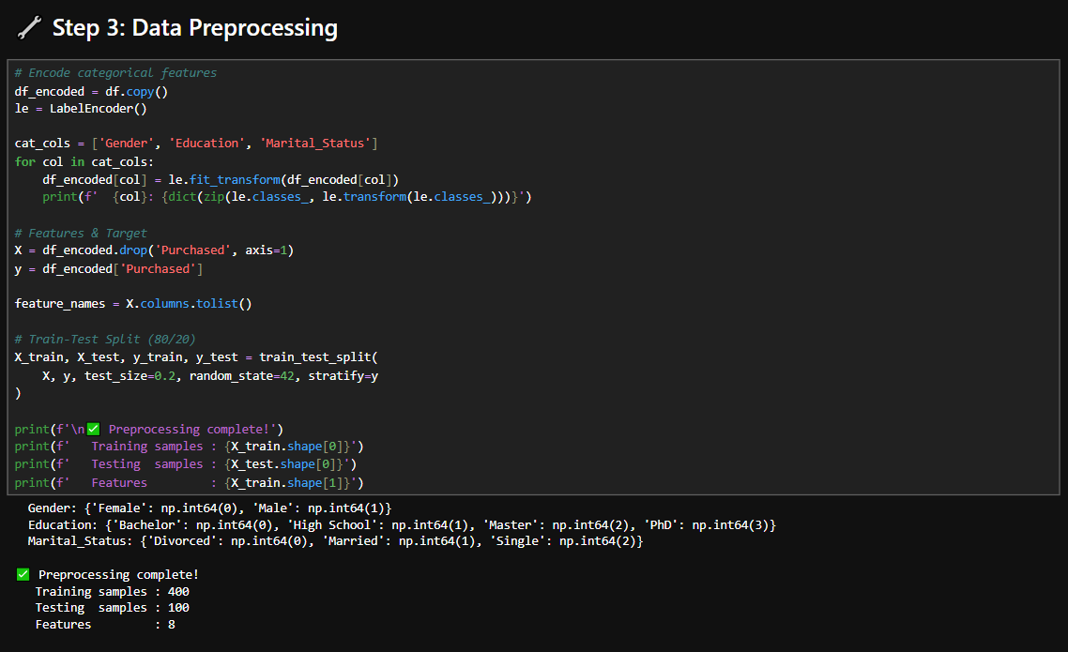
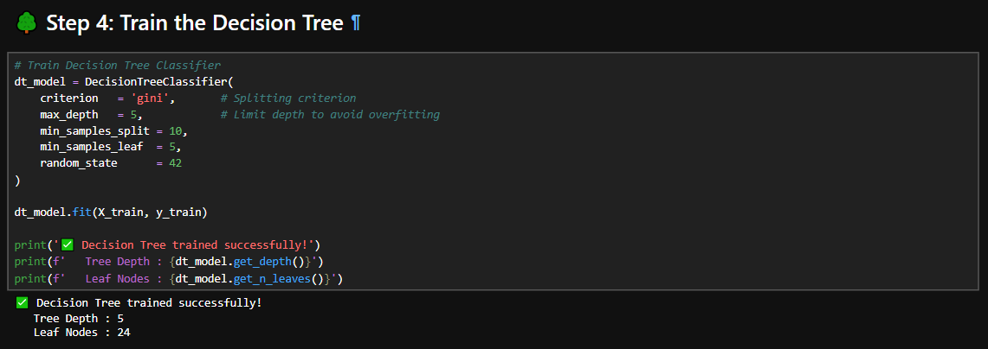
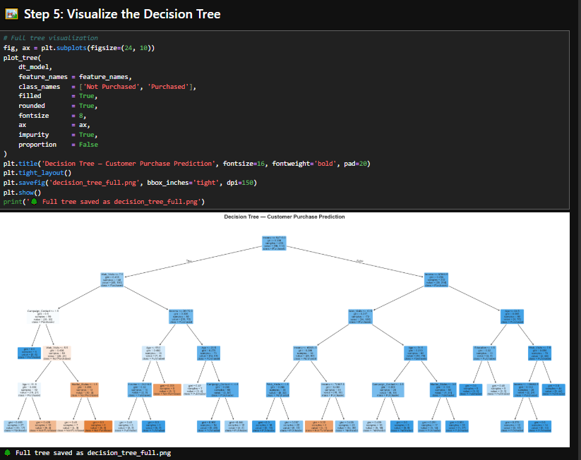
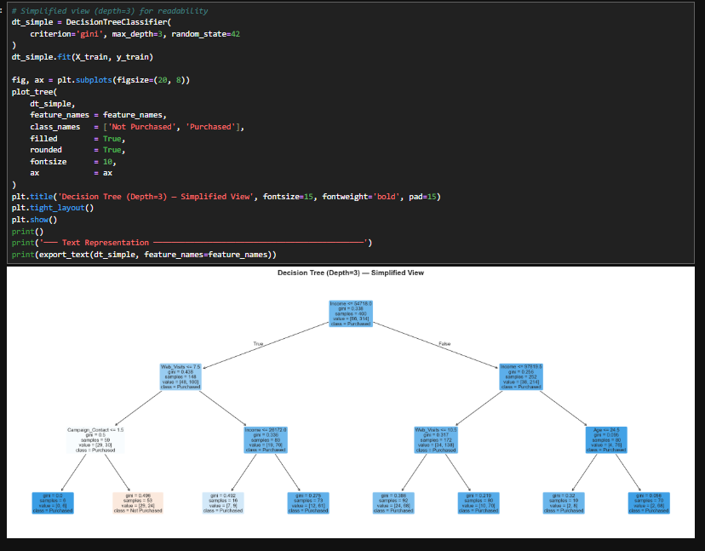
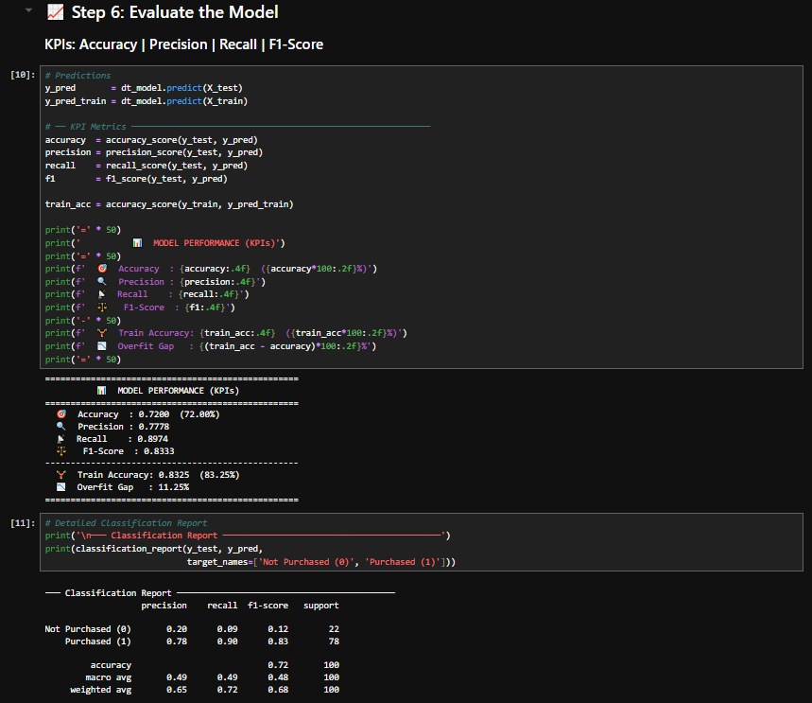
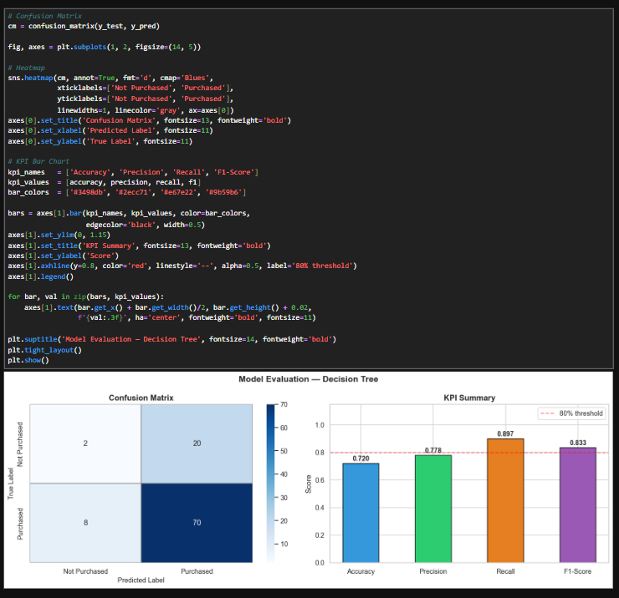
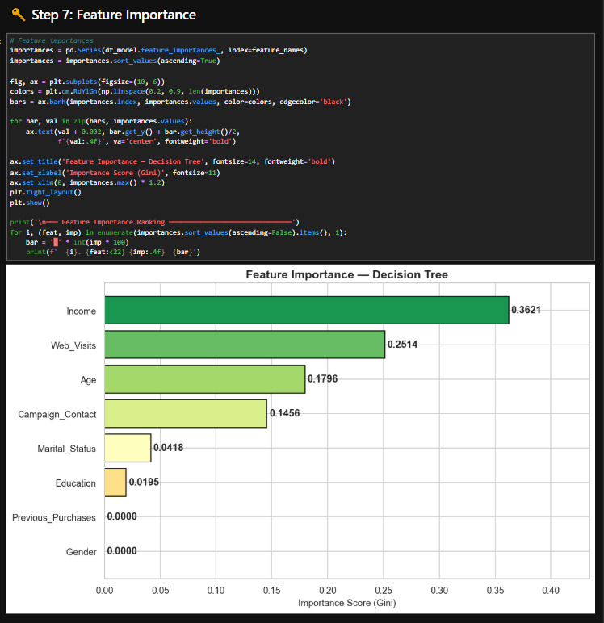

Lab 10

Naïve Bayes & KNN

Objective
To understand Naïve Bayes and K-Nearest Neighbors (KNN) algorithms and their role in classification tasks in data mining and machine learning.

1. Introduction
Naïve Bayes and K-Nearest Neighbors (KNN) are two important supervised learning algorithms used for classification problems. Both are widely used in data mining due to their simplicity, efficiency, and effectiveness on different types of datasets.
Naïve Bayes is a probabilistic model based on Bayes’ Theorem, while KNN is a distance-based algorithm that classifies data based on similarity.

2. Naïve Bayes Classifier

2.1 Concept
Naïve Bayes is a probabilistic classification algorithm based on Bayes’ Theorem. It assumes that all features are independent of each other, which is called the “naïve” assumption.

2.2 Bayes Theorem
- It calculates the probability of a class given input features.
- Used for prediction based on likelihood and prior probability.

2.3 Working of Naïve Bayes
- Calculate prior probabilities for each class.
- Compute likelihood of features for each class.
- Apply Bayes’ formula to find posterior probability.
- Assign class with highest probability.

3. K-Nearest Neighbors (KNN)

3.1 Concept
KNN is a simple, instance-based learning algorithm that classifies a data point based on the majority class of its nearest neighbors.

3.2 Working of KNN
- Choose the value of K (number of neighbors).
- Calculate distance between data points.
- Identify K nearest neighbors.
- Assign class based on majority vote.

3.3 Distance Measures
- Euclidean distance (most common)
- Manhattan distance
- Minkowski distance
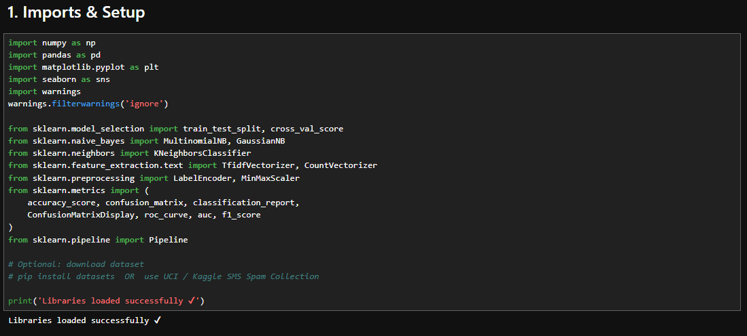
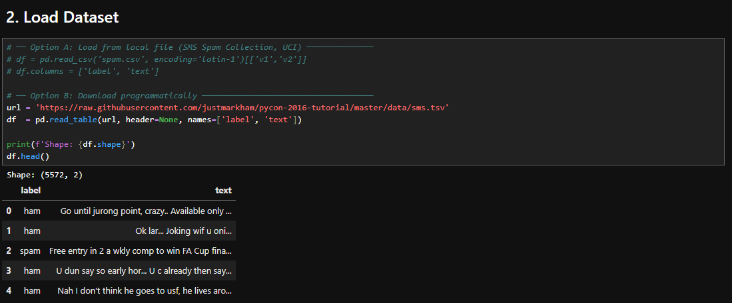
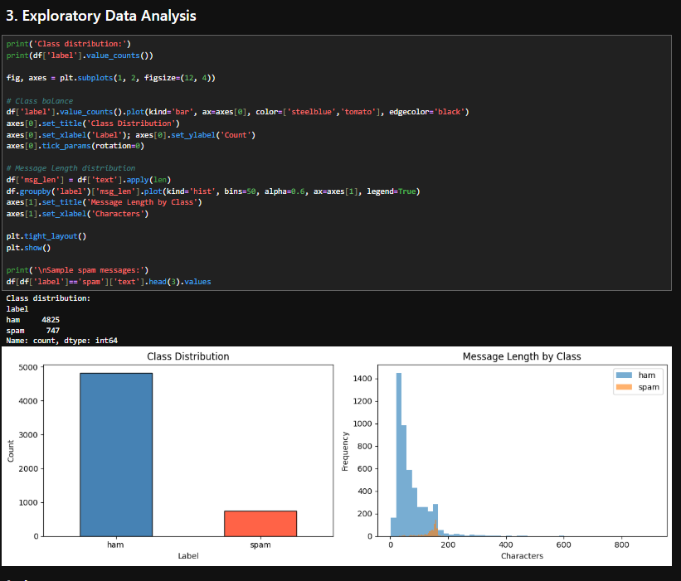
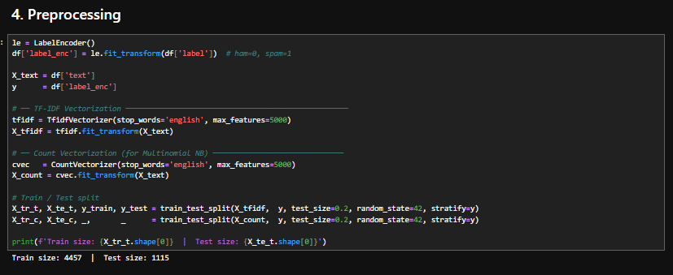
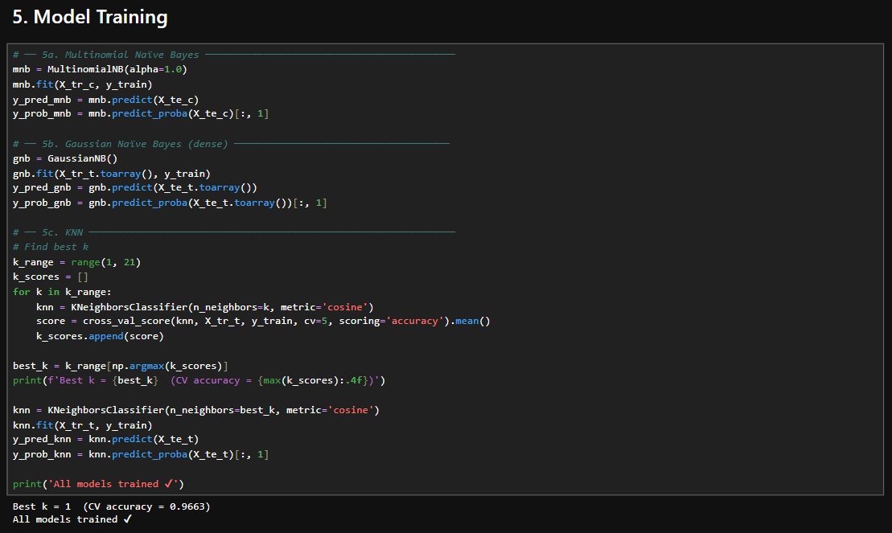
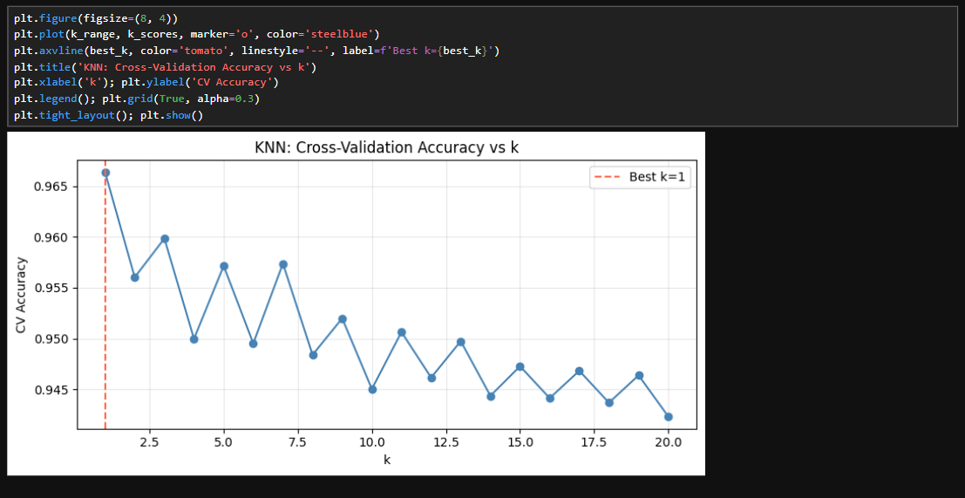
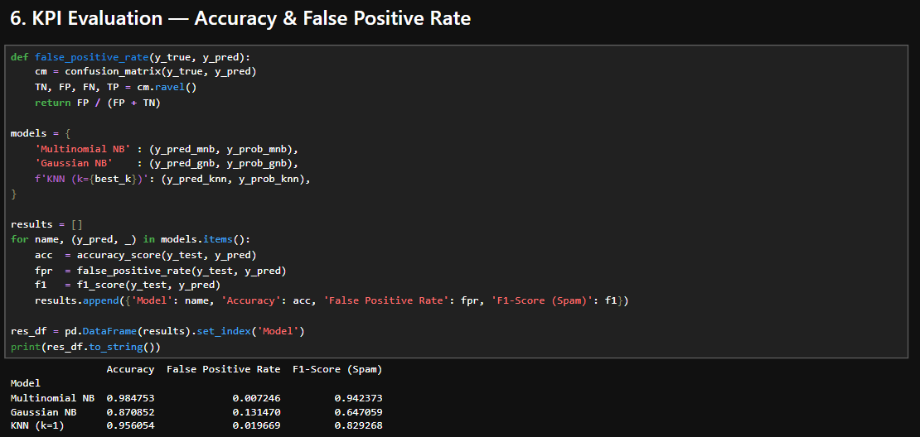
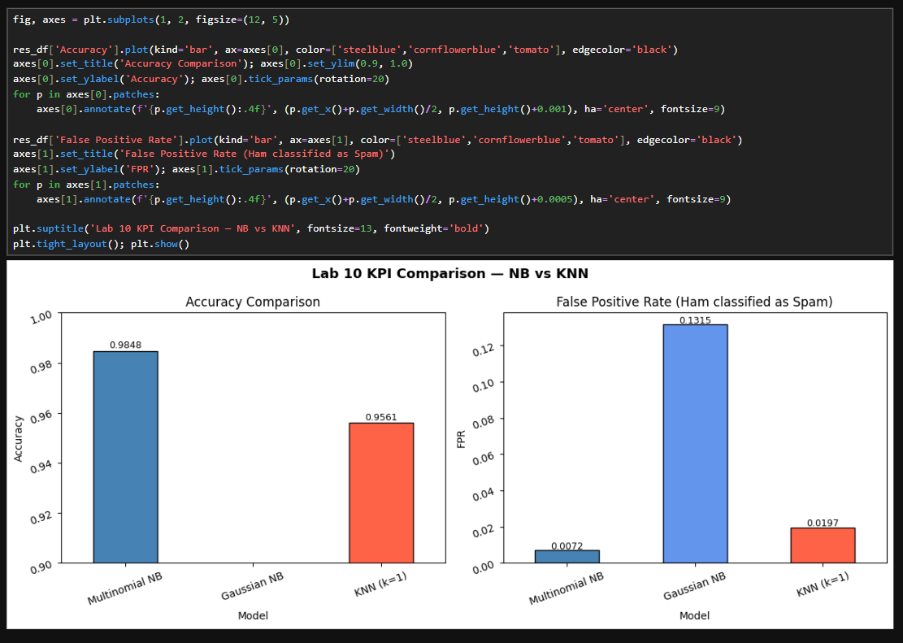
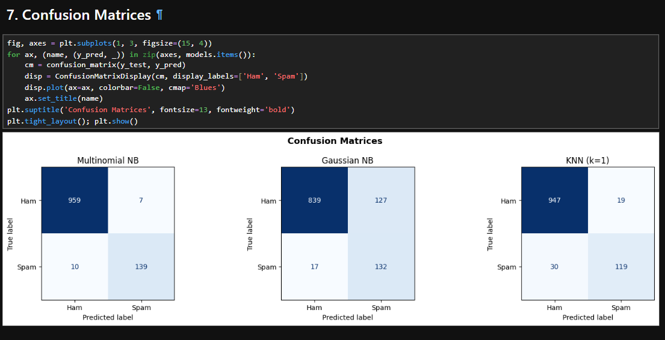

Lab 11

Support Vector Machine (SVM)

Objective
To understand the concept of Support Vector Machine (SVM) and its application in classification problems in data mining and machine learning.

1. Introduction
Support Vector Machine (SVM) is a supervised machine learning algorithm used for classification and regression tasks. In data mining, it is mainly used for classification problems. SVM works by finding the best decision boundary (hyperplane) that separates different classes in the dataset.
The main idea of SVM is to maximize the margin between different classes so that the model becomes more accurate and generalizes well on unseen data.

2. Working of SVM

Step 1: Plot Data Points
- Data points are plotted in an n-dimensional space based on features.

Step 2: Find Hyperplane
- A hyperplane is selected to separate different classes.

Step 3: Maximize Margin
- SVM chooses the hyperplane with the maximum distance between classes.
- These boundary points are called support vectors.

Step 4: Classification
- New data points are classified based on which side of the hyperplane they fall.

3. Key Concepts

Hyperplane
- A decision boundary that separates different classes.

Support Vectors
- Data points closest to the hyperplane.
- They influence the position of the hyperplane.

Margin
- The distance between the hyperplane and support vectors.
- Larger margin improves model performance.

4. Types of SVM

Linear SVM
- Used when data is linearly separable.

Non-Linear SVM
- Used when data is not linearly separable.
- Uses kernel functions to transform data.

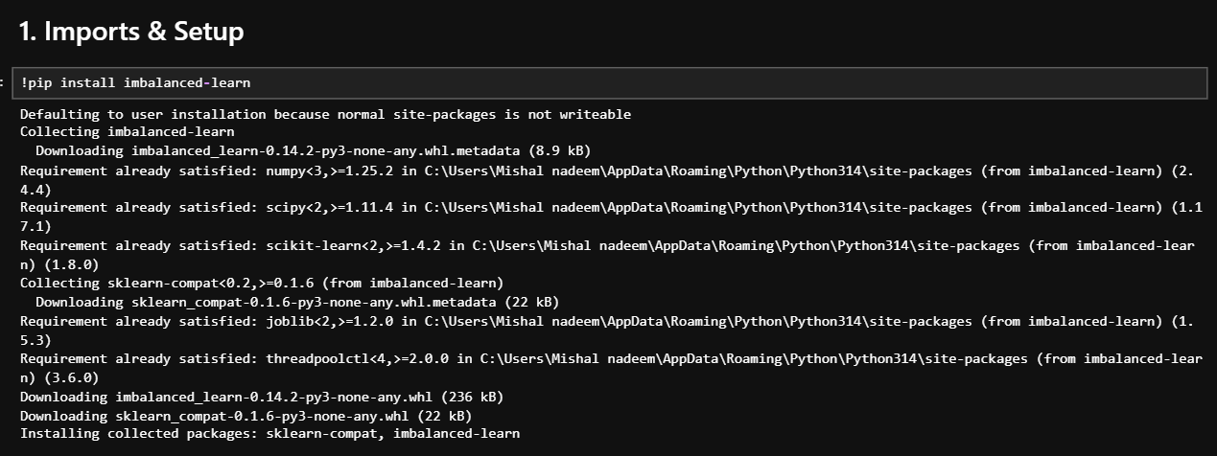
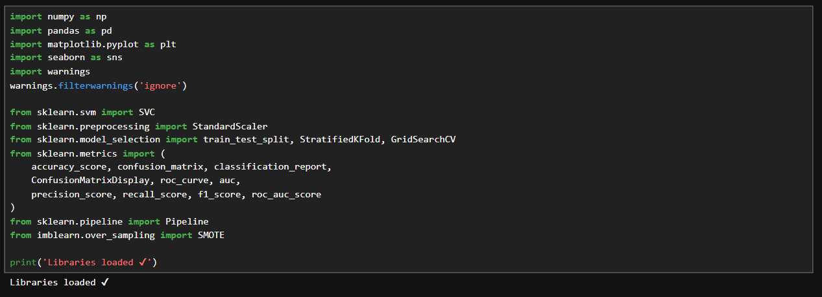
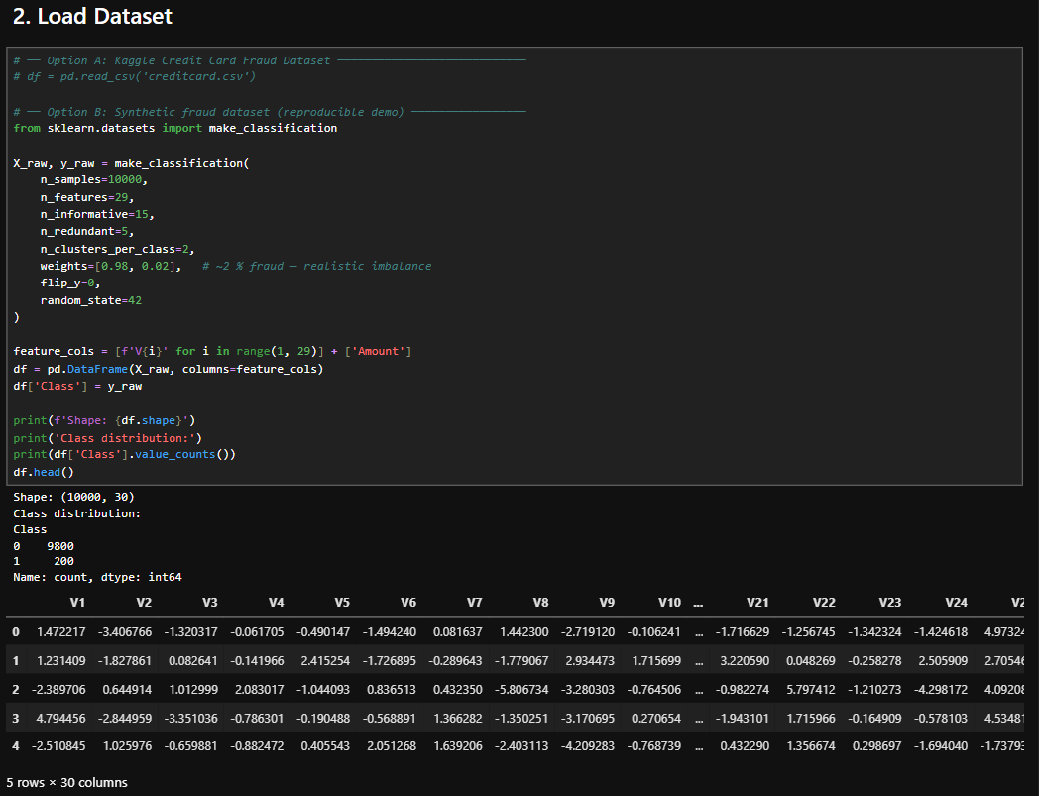
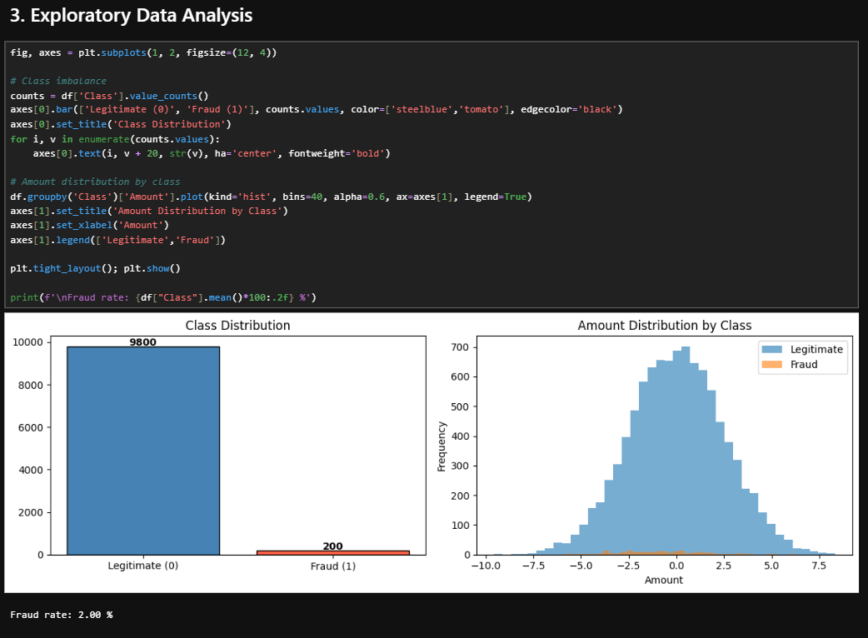
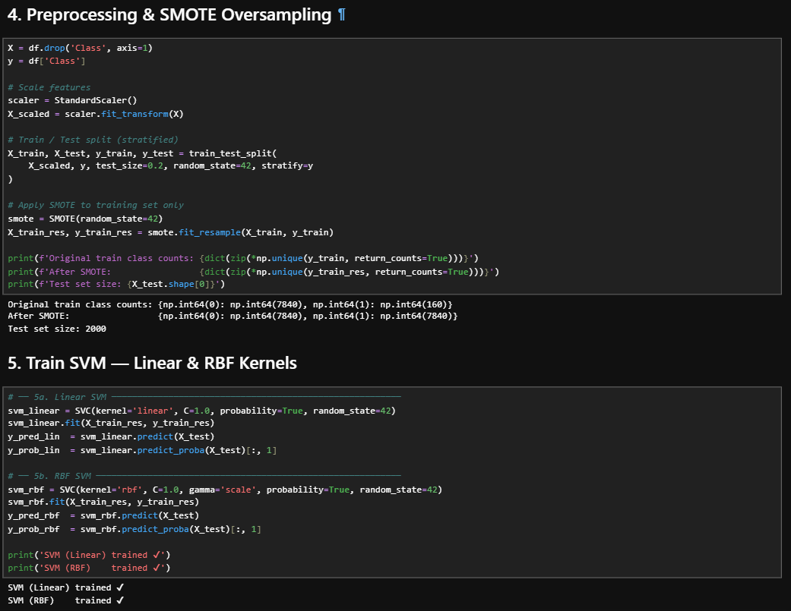
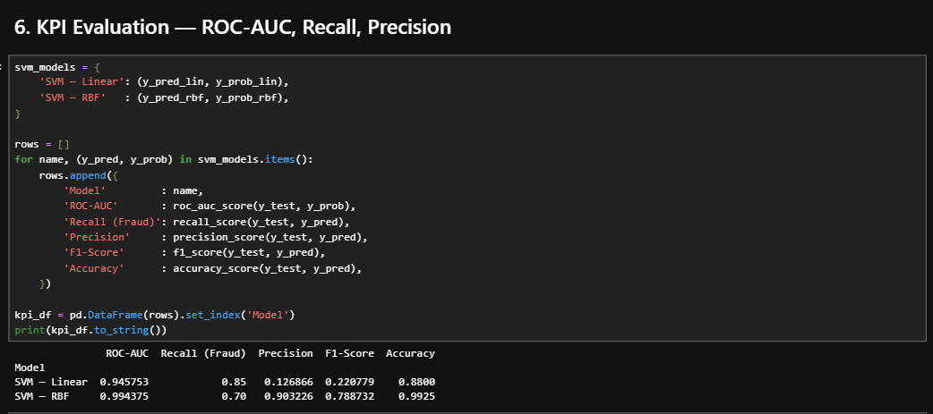
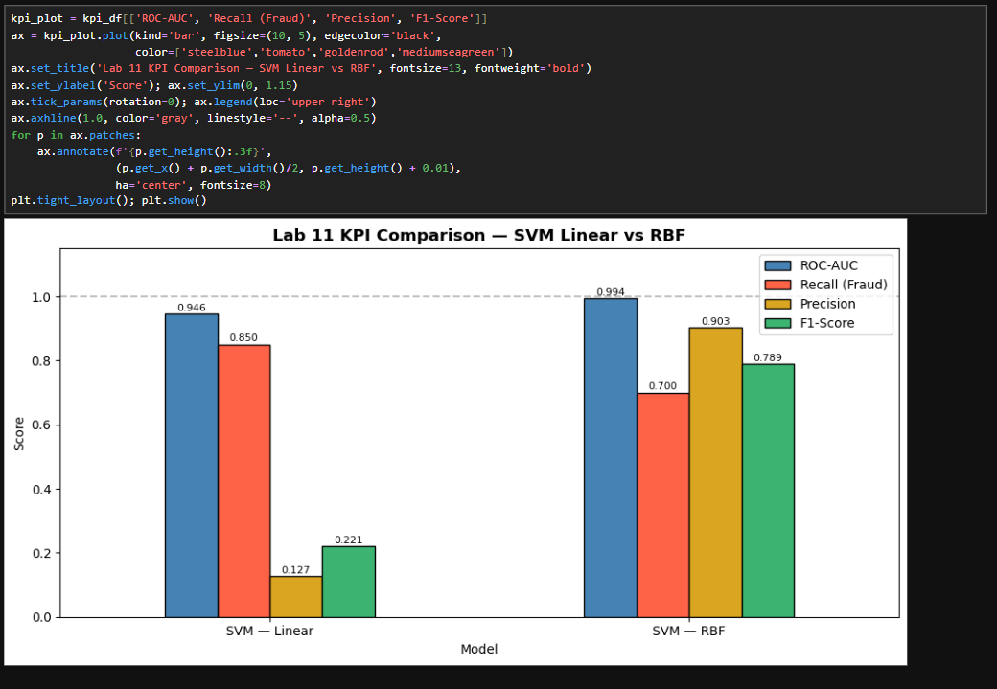
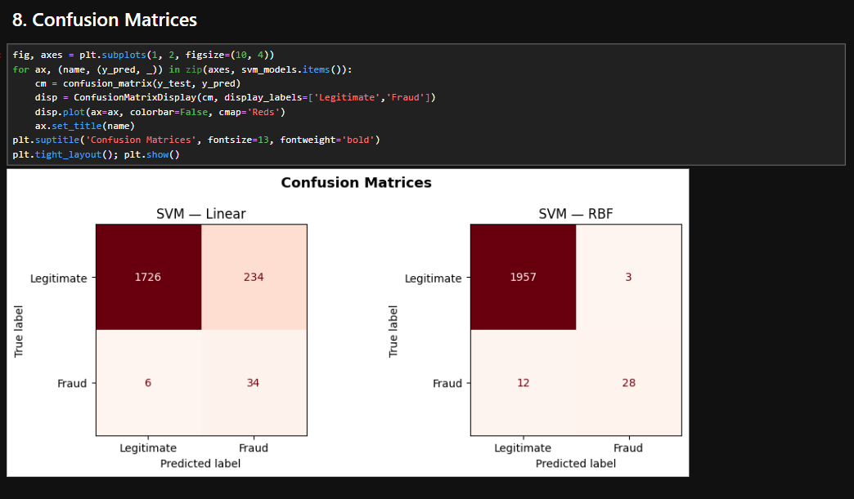

Lab 12

K-Means & Hierarchical Clustering

Objective
To understand clustering techniques, specifically K-Means and Hierarchical Clustering, used for grouping similar data points in data mining.

1. Introduction
Clustering is an unsupervised learning technique used in data mining to group similar data points together based on their characteristics. Unlike classification, clustering does not require predefined labels. It helps in discovering hidden patterns and structures in data.
K-Means and Hierarchical Clustering are two widely used clustering algorithms.

2. K-Means Clustering

2.1 Concept
K-Means is a centroid-based clustering algorithm that divides data into K clusters based on similarity.

2.2 Working of K-Means

Step 1: Choose K
- Select the number of clusters (K).

Step 2: Initialize Centroids
- Randomly select K points as initial cluster centers.

Step 3: Assign Clusters
- Assign each data point to the nearest centroid.

Step 4: Update Centroids
- Recalculate centroids based on assigned points.

Step 5: Repeat
- Repeat steps until centroids no longer change.

3. Hierarchical Clustering

3.1 Concept
Hierarchical Clustering builds a tree-like structure (dendrogram) to represent nested clusters.

3.2 Types

Agglomerative (Bottom-Up)
- Each data point starts as a single cluster.
- Clusters are merged step by step.

Divisive (Top-Down)
- All data starts in one cluster.
- It is divided into smaller clusters.

3.3 Working of Hierarchical Clustering
- Calculate distance between data points.
- Merge or split clusters based on similarity.
- Continue until stopping condition is met.
- Represent results using a dendrogram.

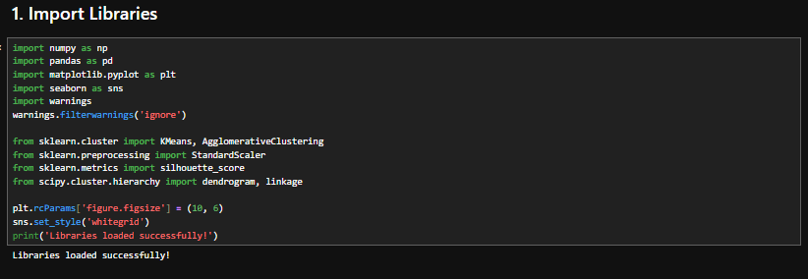
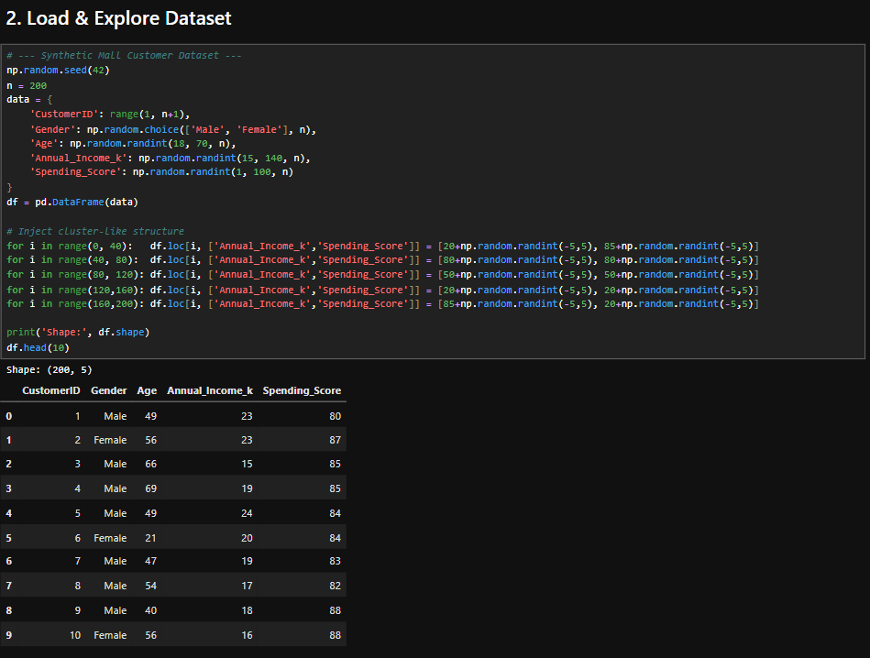
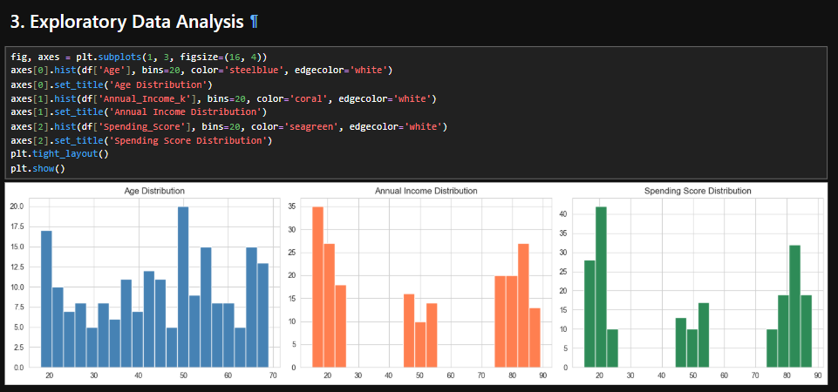
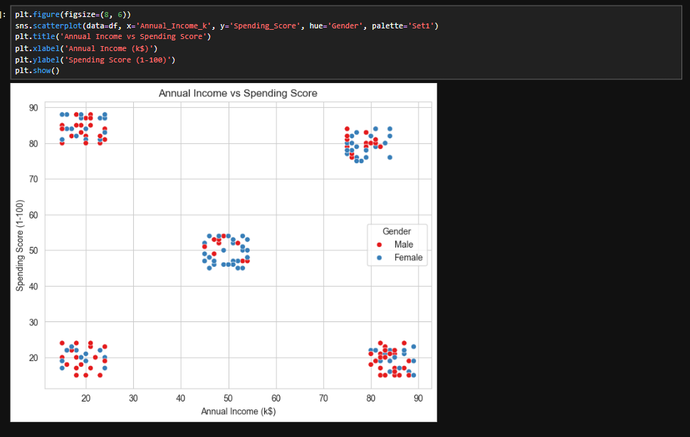
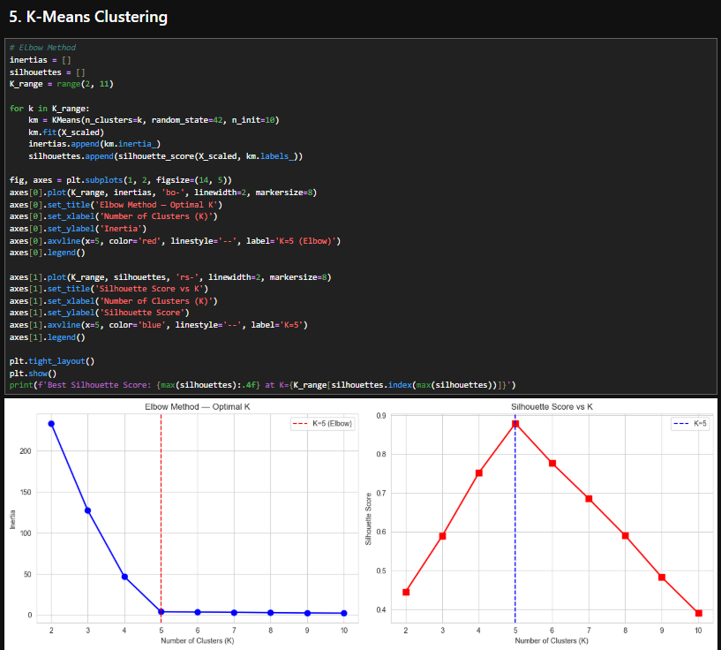
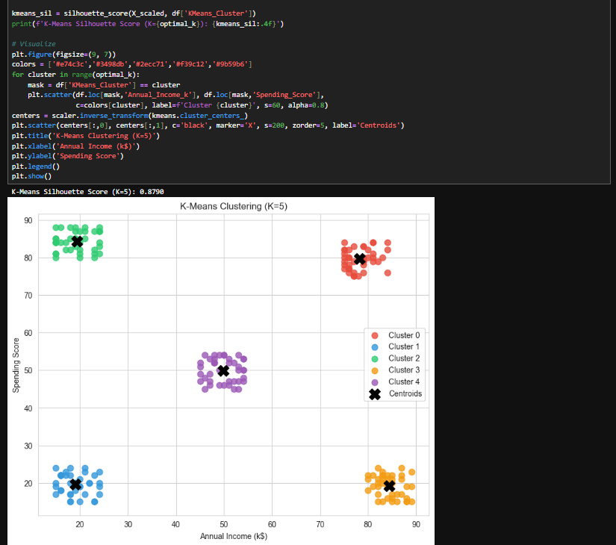

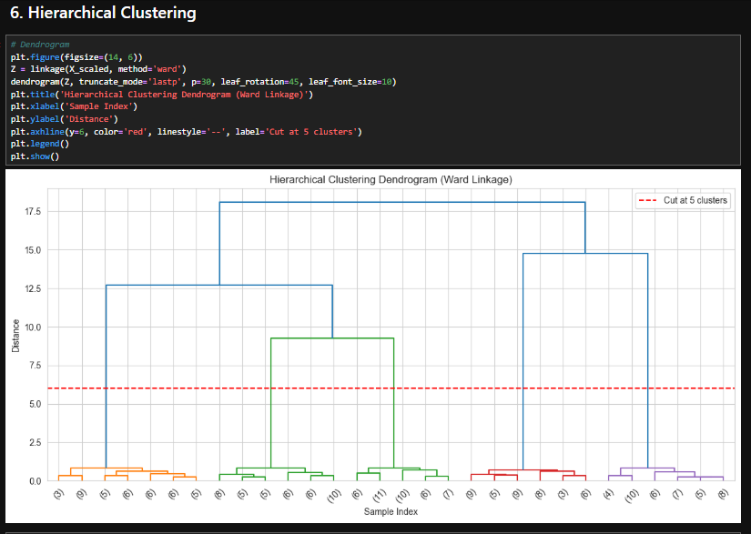
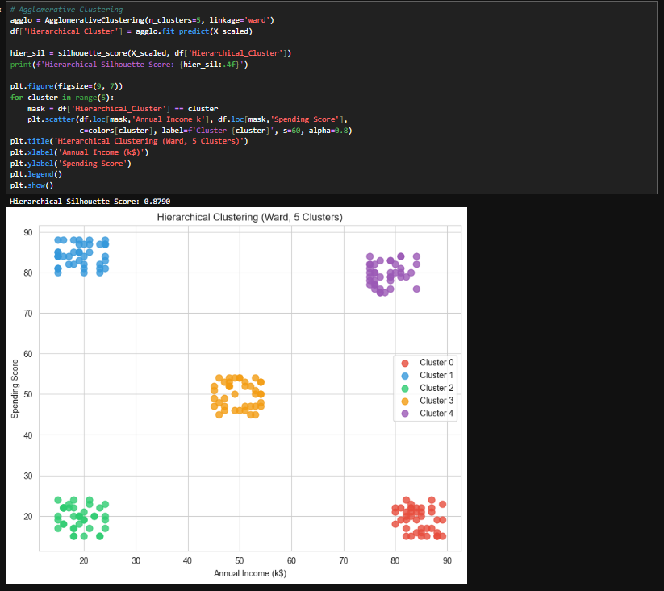
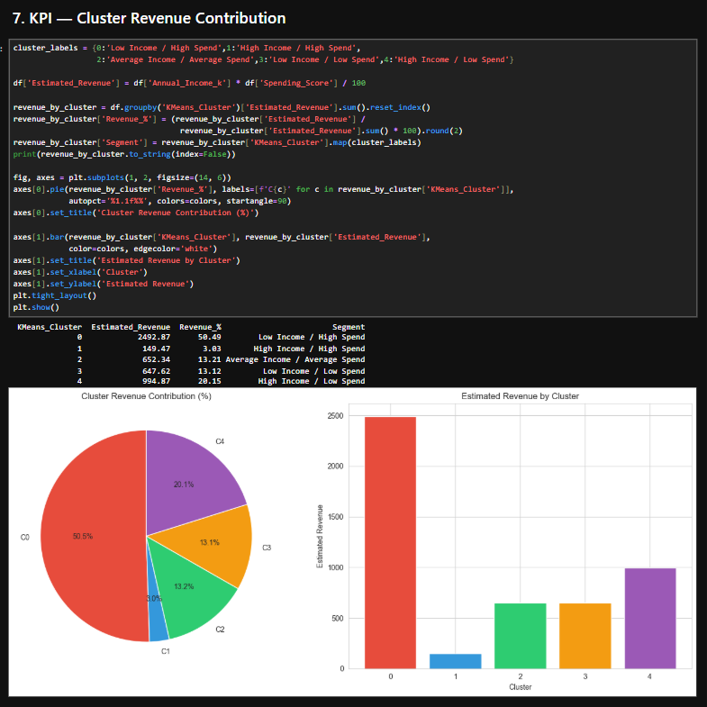

Lab 13

Outlier Detection

Objective
To understand the concept of outliers in data mining and learn different techniques used to detect and handle outliers in datasets.

1. Introduction
Outliers are data points that significantly differ from the rest of the dataset. They may be much higher or lower than normal values and can distort analysis results if not handled properly. Outlier detection is an important step in data preprocessing because it improves data quality and ensures accurate model performance.
Outliers can occur due to errors in data collection, measurement issues, or genuine rare events.

2. Types of Outliers

2.1 Point Outliers
- A single data point that is significantly different from other values.
- Example: A salary of 1,000,000 in a dataset where most salaries are 30,000–50,000.

2.2 Contextual Outliers
- A data point that is abnormal in a specific context.
- Example: High temperature in winter season.

2.3 Collective Outliers
- A group of data points that behave unusually compared to the rest of the dataset.

3. Causes of Outliers
- Data entry errors.
- Measurement errors.
- Equipment malfunction.
- Fraudulent activity.
- Natural variation in data.

4. Techniques for Outlier Detection

4.1 Statistical Methods
- Use mean, median, standard deviation.
- Z-score method to detect extreme values.

4.2 Visualization Methods
- Box plots.
- Scatter plots.
- Histograms.

4.3 Distance-Based Methods
- Identify points far away from clusters.
- Used in KNN-based approaches.

4.4 Clustering-Based Methods
- Outliers do not belong to any cluster or form very small clusters.

4.5 Machine Learning Methods
- Isolation Forest.
- Local Outlier Factor (LOF).

5. Handling Outliers
- Remove outliers from dataset.
- Cap or trim extreme values.
- Transform data using log or scaling.
- Replace with mean or median values.

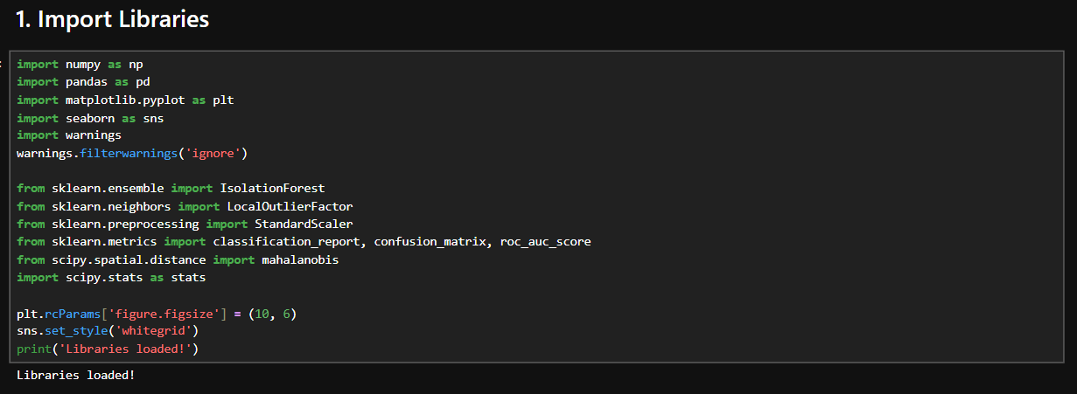
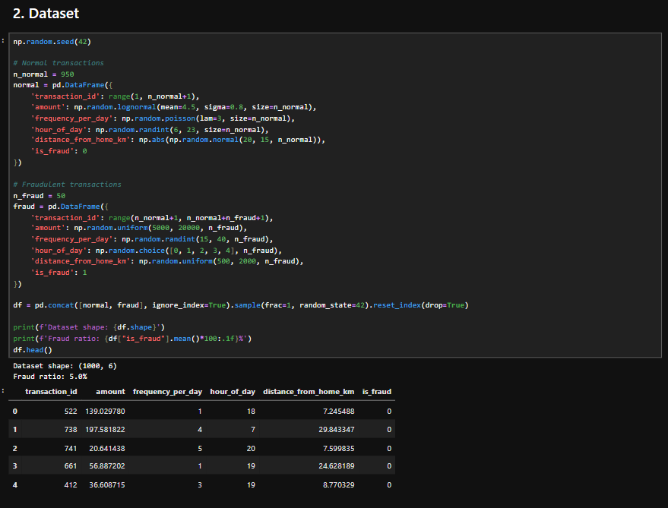
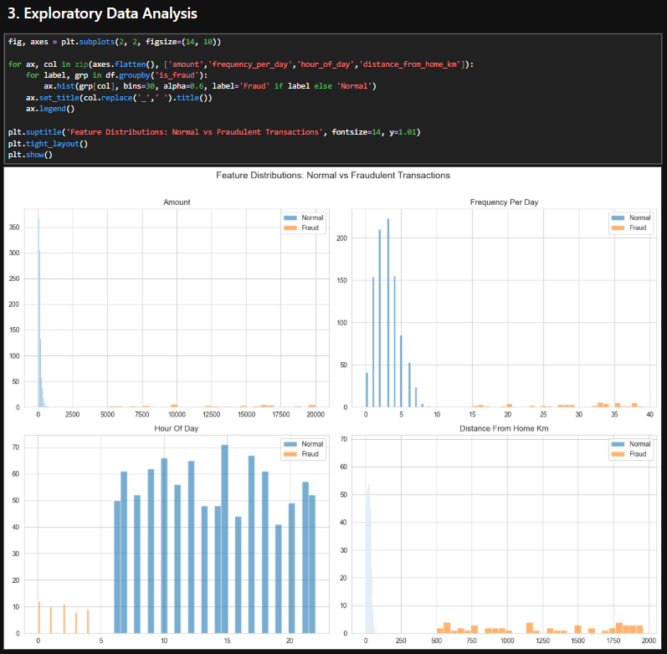
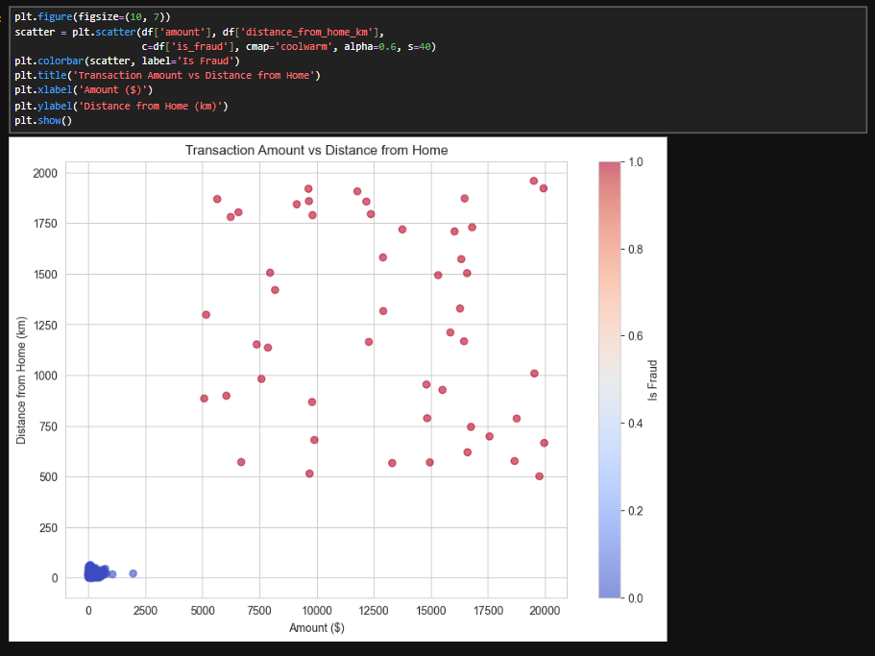
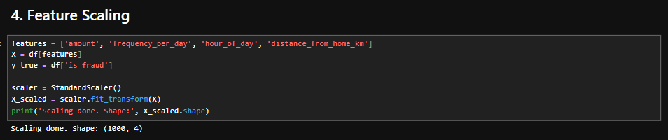
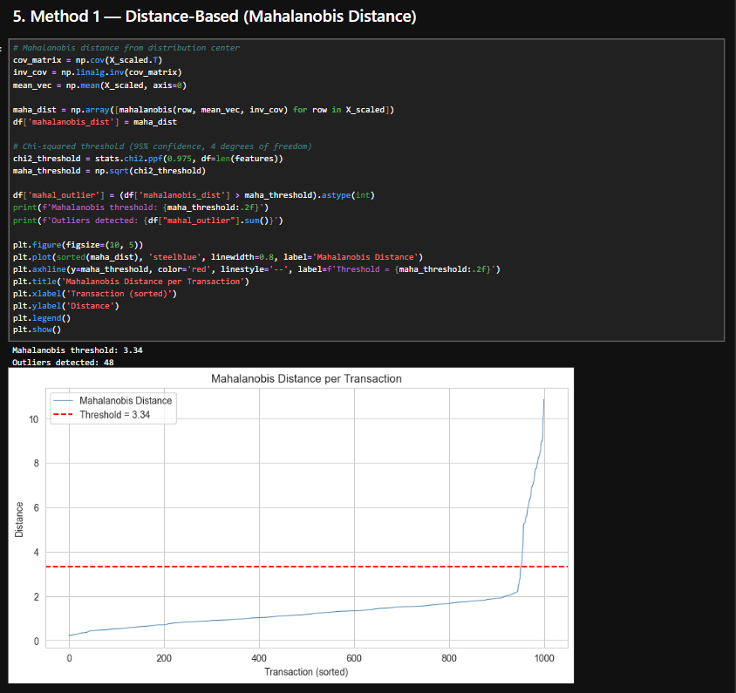
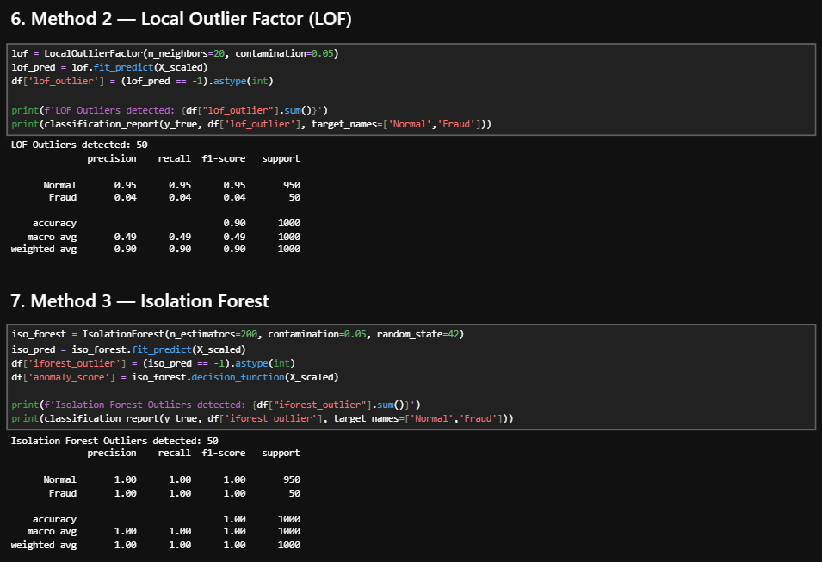
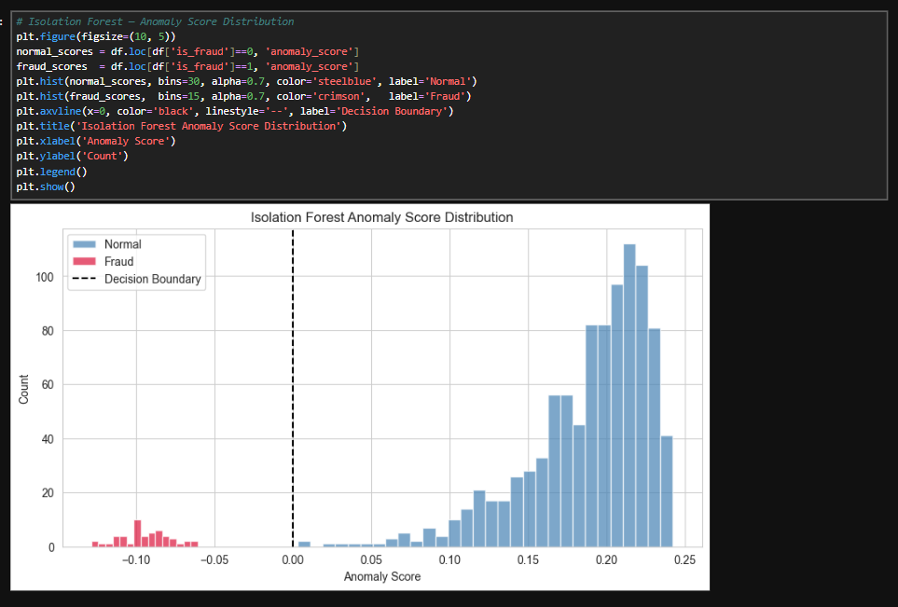
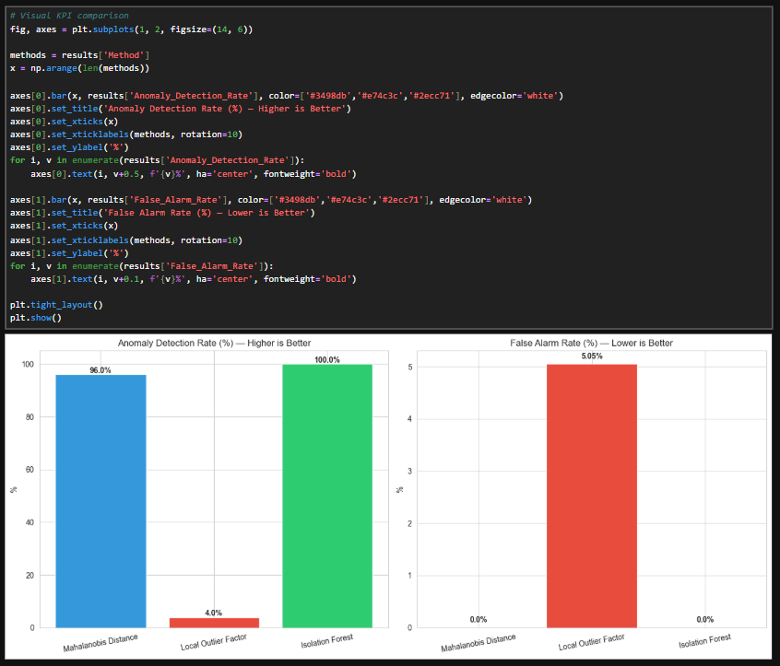

Lab 14

Data Scraping & Sentiment Analysis

Objective
To understand the basics of data scraping and sentiment analysis and how they are used in data mining to collect and analyze textual data from online sources.

1. Introduction
Data Scraping and Sentiment Analysis are important techniques in modern data mining. Data scraping is used to collect data from websites or online sources, while sentiment analysis is used to determine the emotional tone behind text data such as positive, negative, or neutral opinions.
These techniques are widely used in social media analysis, market research, and customer feedback analysis.

2. Data Scraping

2.1 Concept
Data scraping is the process of extracting large amounts of data from websites automatically using tools or scripts.

2.2 Sources of Data
- Websites and blogs
- Social media platforms
- Online reviews
- News portals
- E-commerce sites

2.3 Process of Data Scraping
- Identify target website.
- Extract required data (text, images, or tables).
- Store data in structured format (CSV, database, etc.).
- Clean and preprocess collected data.

3. Sentiment Analysis

3.1 Concept
Sentiment analysis is a natural language processing technique used to identify and classify opinions or emotions expressed in text.

3.2 Types of Sentiment
- Positive sentiment
- Negative sentiment
- Neutral sentiment

3.3 Working of Sentiment Analysis
- Collect text data (reviews, tweets, comments).
- Preprocess text (remove noise, stopwords, punctuation).
- Convert text into numerical features.
- Apply machine learning or lexicon-based methods.
- Classify sentiment as positive, negative, or neutral.

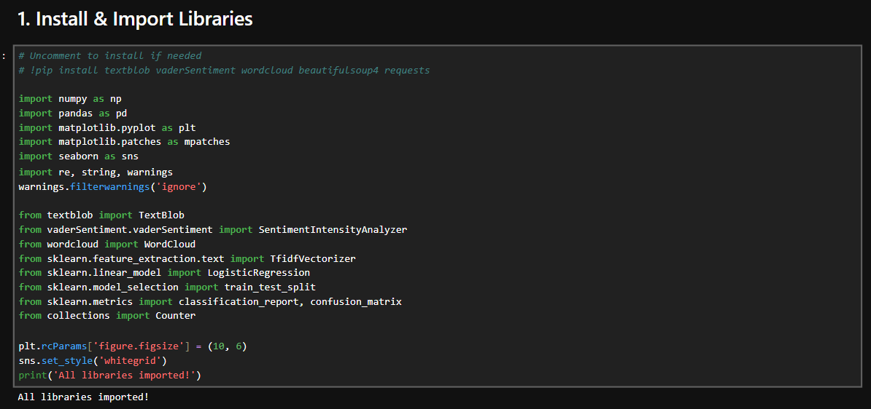
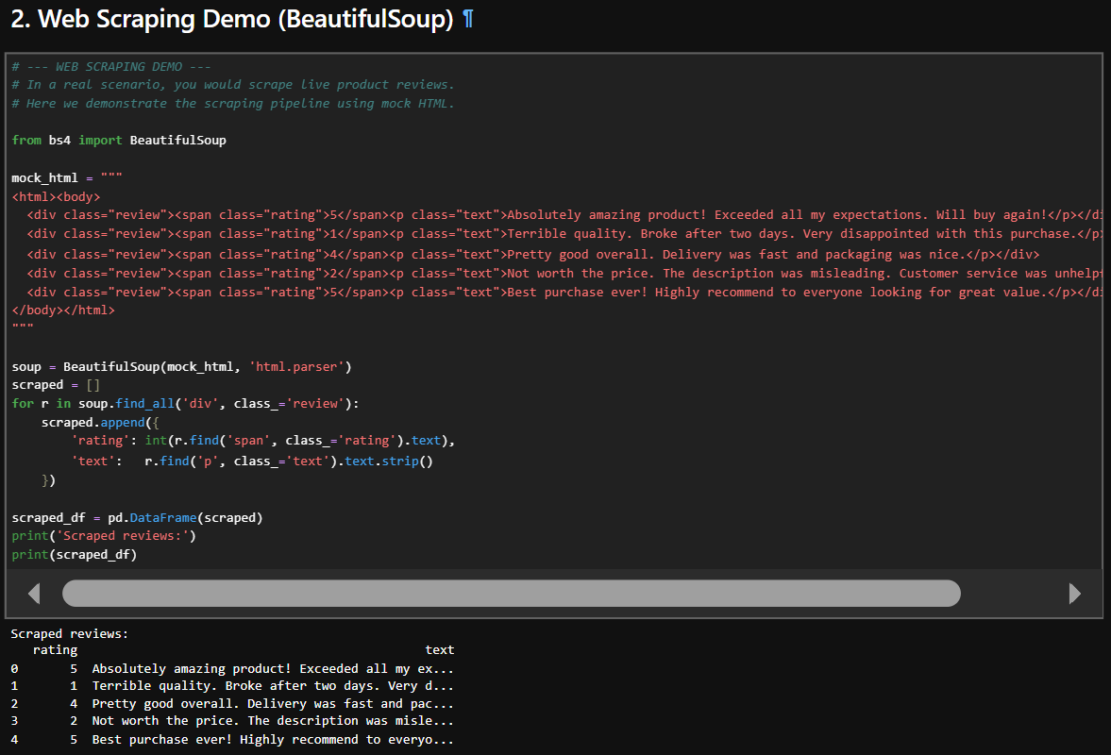
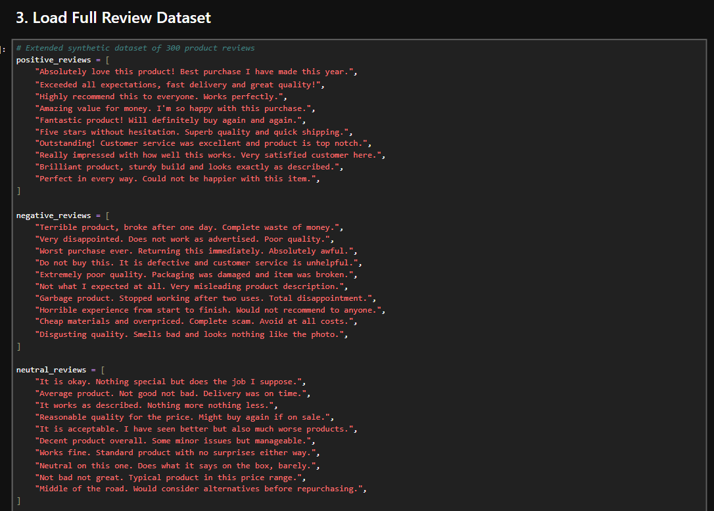
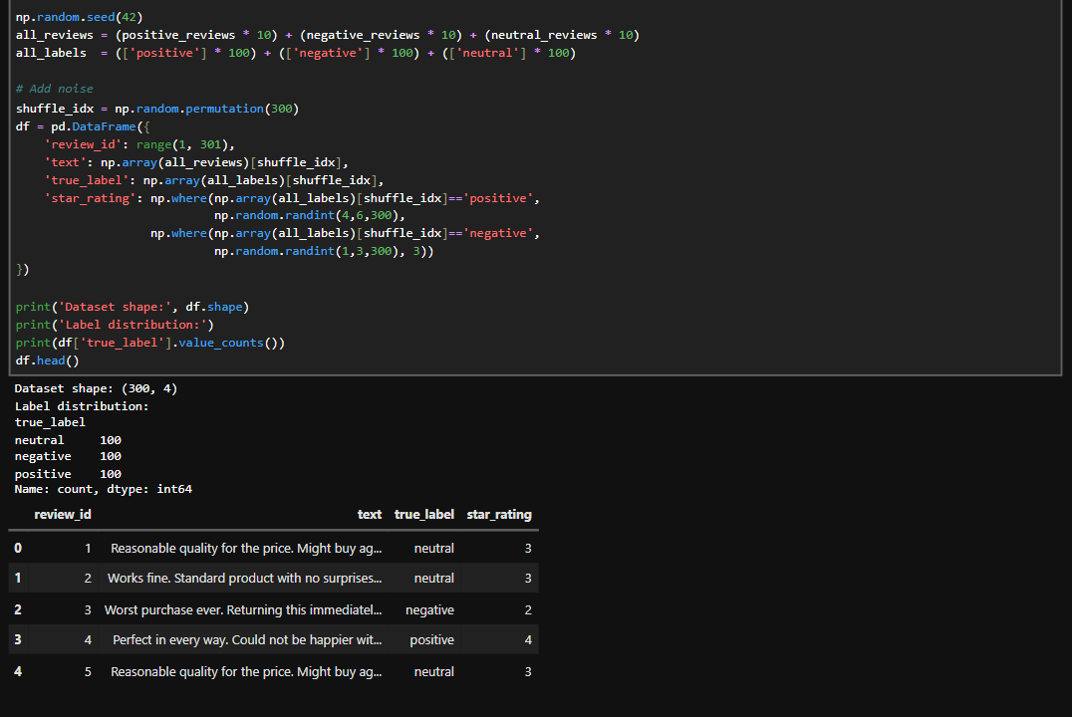
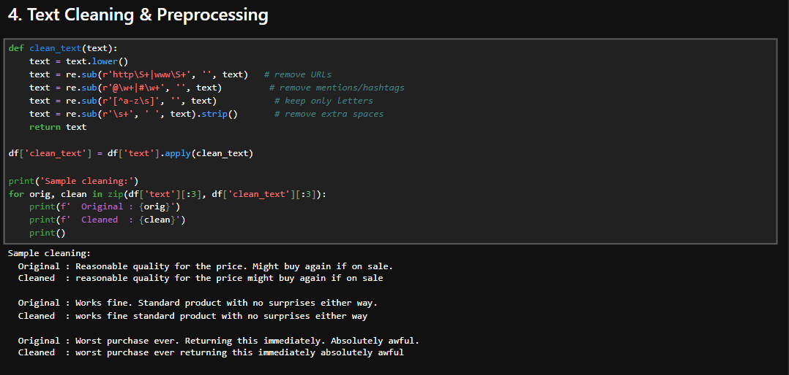
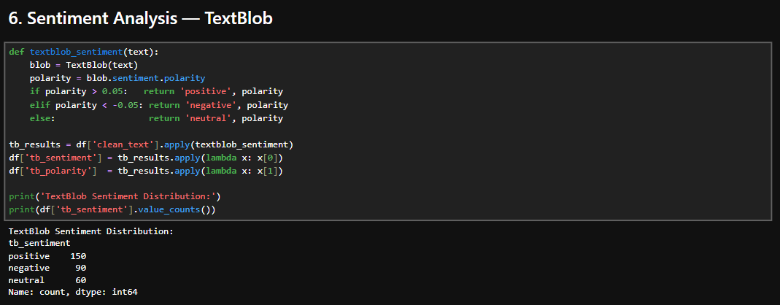
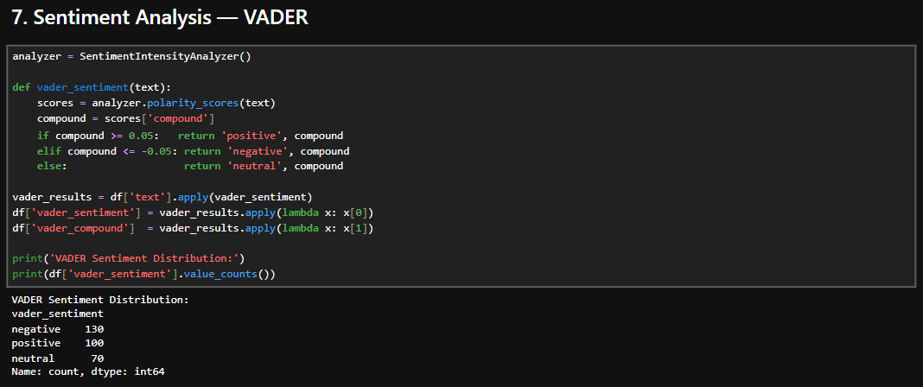
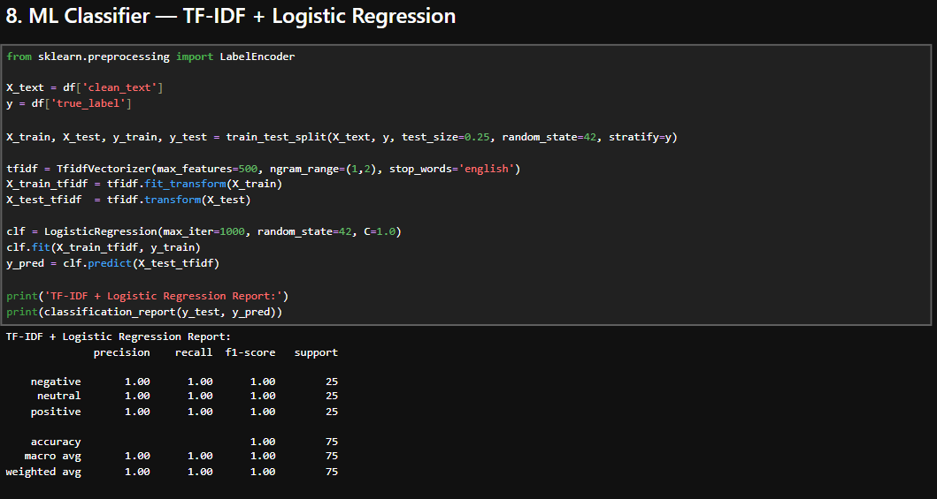
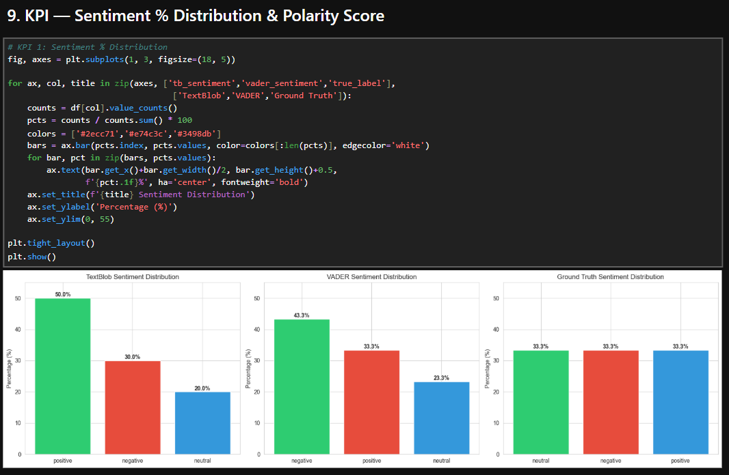
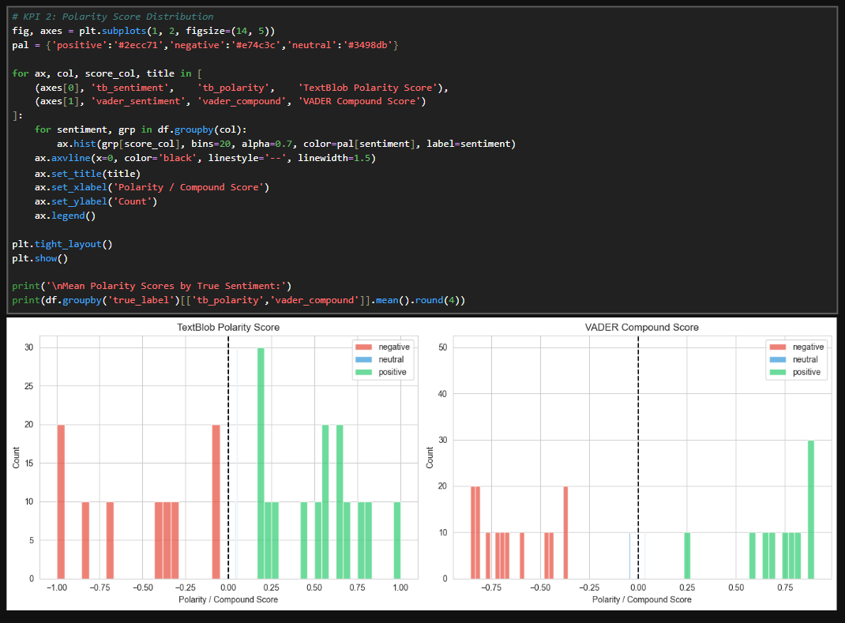

Lab 15

Performance Comparison of Models

Objective
To understand how to evaluate and compare different machine learning models using performance metrics in data mining.

1. Introduction
In data mining and machine learning, multiple models are often trained to solve the same problem. However, not all models perform equally well. Therefore, it is important to evaluate and compare models using standard performance metrics to select the best one.
Model comparison helps in identifying which algorithm gives the highest accuracy, better predictions, and more reliable results on unseen data.

2. Importance of Model Comparison
- Helps select the best performing model.
- Improves prediction accuracy.
- Ensures better decision-making.
- Reduces overfitting or underfitting issues.
- Increases reliability of results.

3. Performance Metrics

3.1 Accuracy
- Measures the percentage of correct predictions.
- Higher accuracy indicates better performance.

3.2 Precision
- Measures how many predicted positives are actually correct.
- Important in classification problems.

3.3 Recall
- Measures how many actual positives are correctly predicted.
- Useful when missing positive cases is critical.

3.4 F1 Score
- Harmonic mean of precision and recall.
- Useful when data is imbalanced.

3.5 Confusion Matrix
- Table showing correct and incorrect predictions.
- Includes True Positive, True Negative, False Positive, False Negative.

4. Model Comparison Process

Step 1: Train Models
- Train multiple machine learning models on the same dataset.

Step 2: Predict Results
- Generate predictions using each model.

Step 3: Evaluate Metrics
- Calculate accuracy, precision, recall, and F1-score.

Step 4: Compare Results
- Compare all models based on evaluation metrics.

Step 5: Select Best Model
- Choose the model with the best overall performance.

5. Common Models for Comparison
- Decision Tree
- Naïve Bayes
- K-Nearest Neighbors (KNN)
- Support Vector Machine (SVM)
- Random Forest

